**1.Perform steps of installation of Wordpress.**

**Steps 1 :- Download the XAMPP servers.**

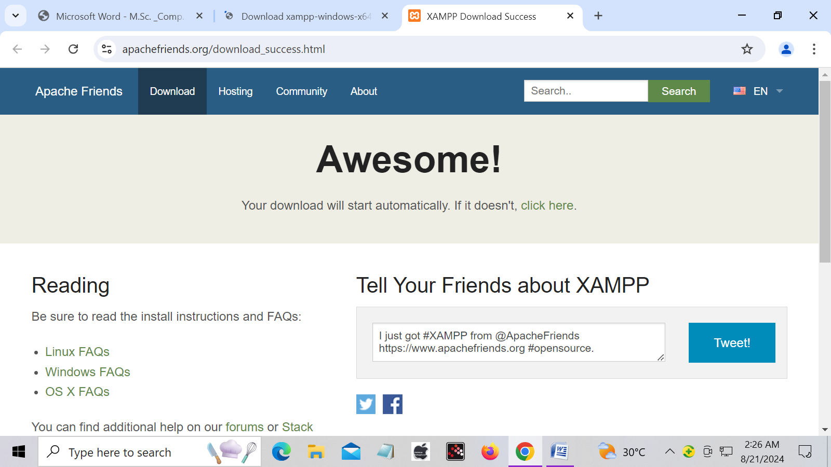

**Steps 2 :- After download the Xampp server install the Xampp.**

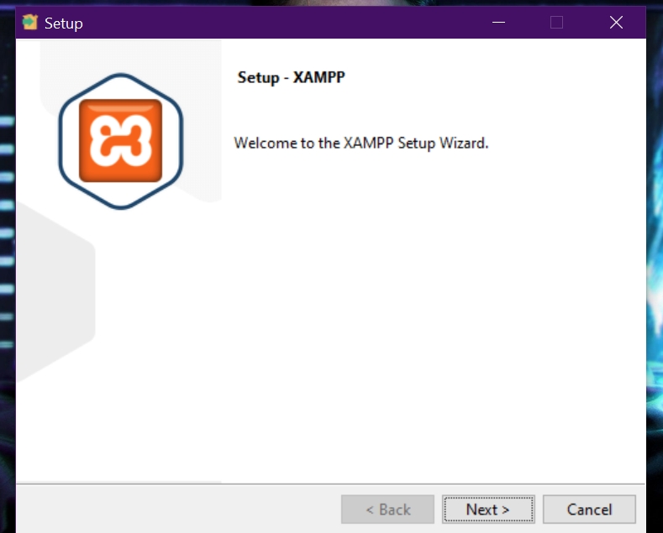

**Steps 3 :- Dwonload the Wordpress & install .**

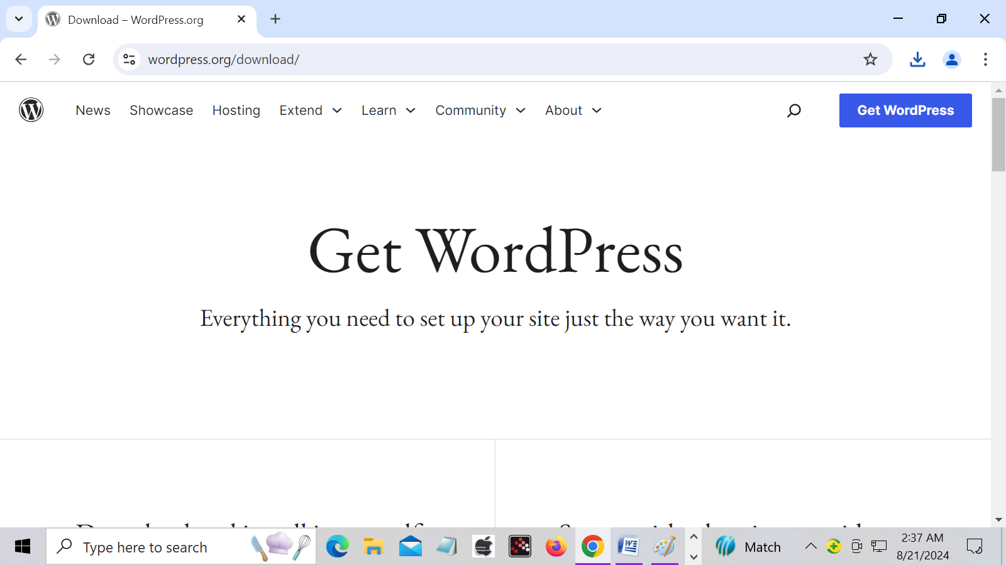

**Steps 4 :- After dwonload Wordpress this zip file compress the xampp server folder.**

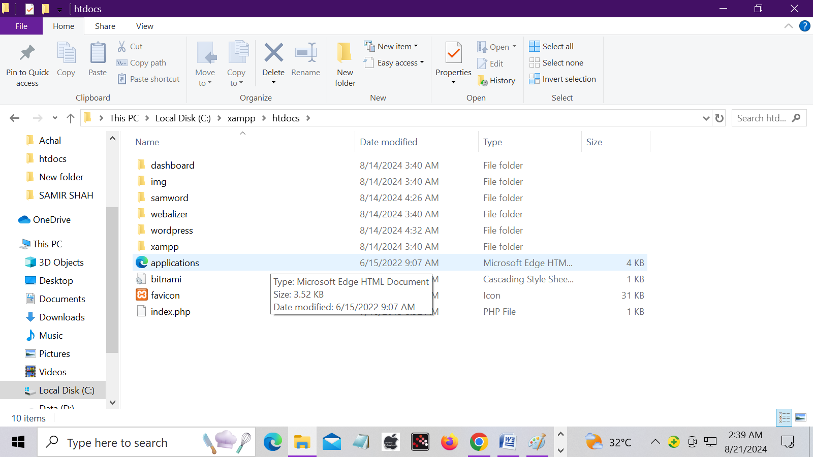

**Steps 5 :- Opne xampp control panel and start the Apache & MySQL server.**

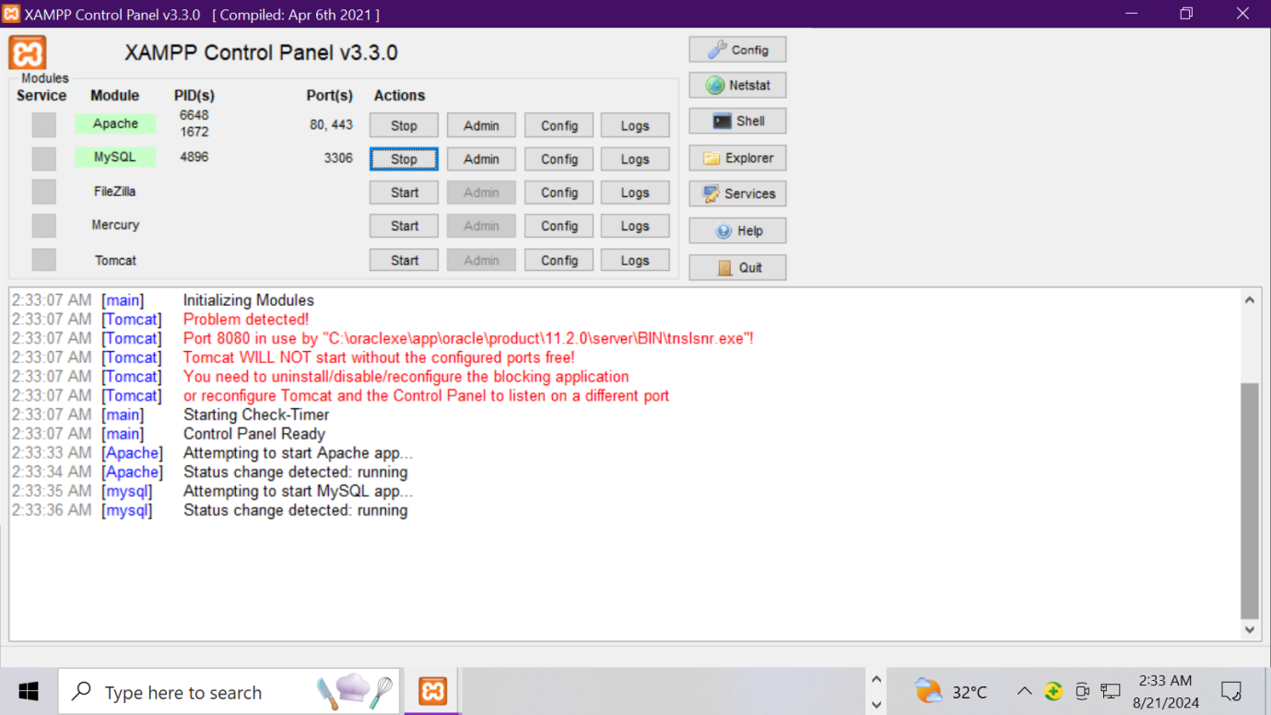

**Steps 6 :- opne the google chrome and run this command (localhost/phpmyadmin) and creat the database.**

**A.click database option & creat database.**

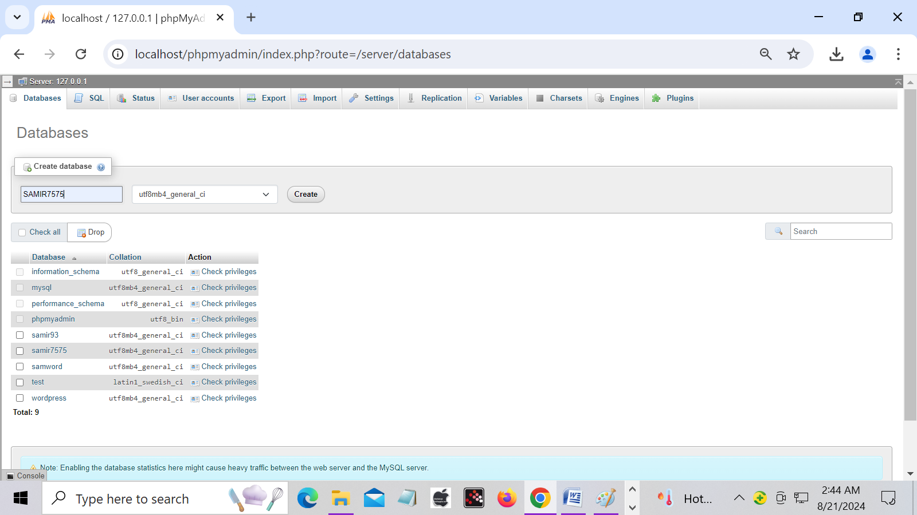

**Steps 7 :- Opne the google chrome and run this command(localhost/wordpress/wp-sdmin) & select the language**

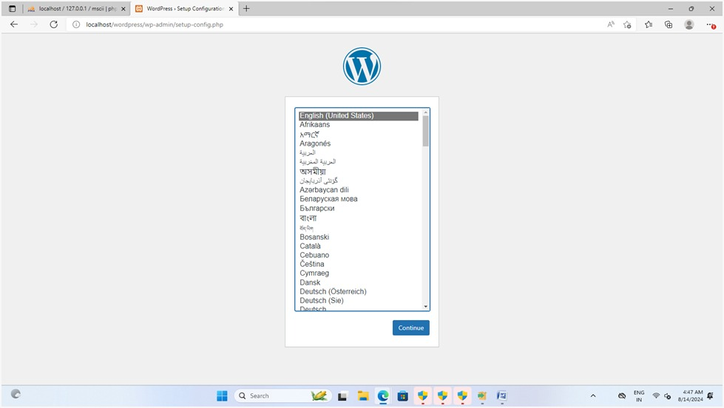

**Steps 8 :- Create Username or database host name.**

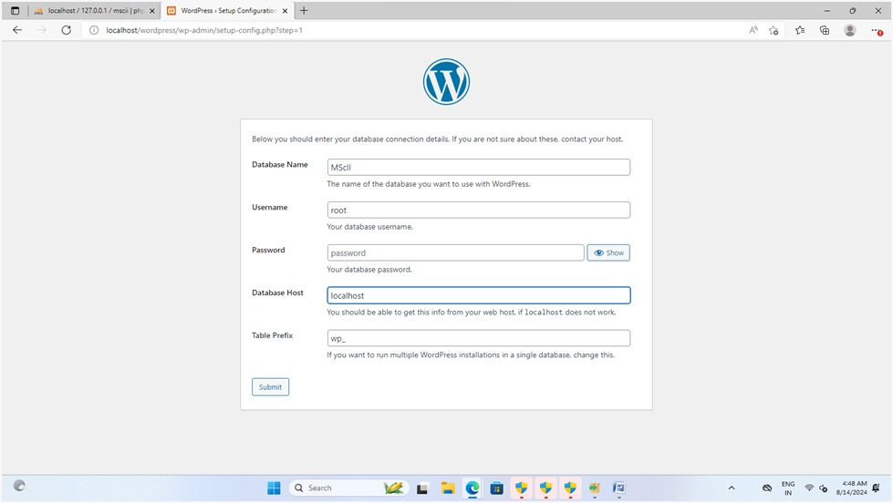

**Steps 9 :- after create username then create password or email.**

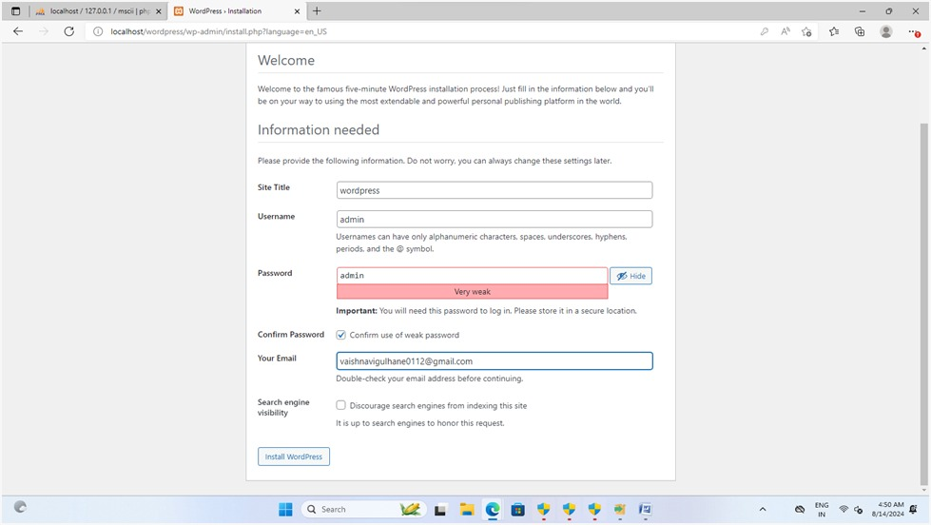

**Steps 10 :- After create username or password then login to username or password and opne the wordpress home page.**

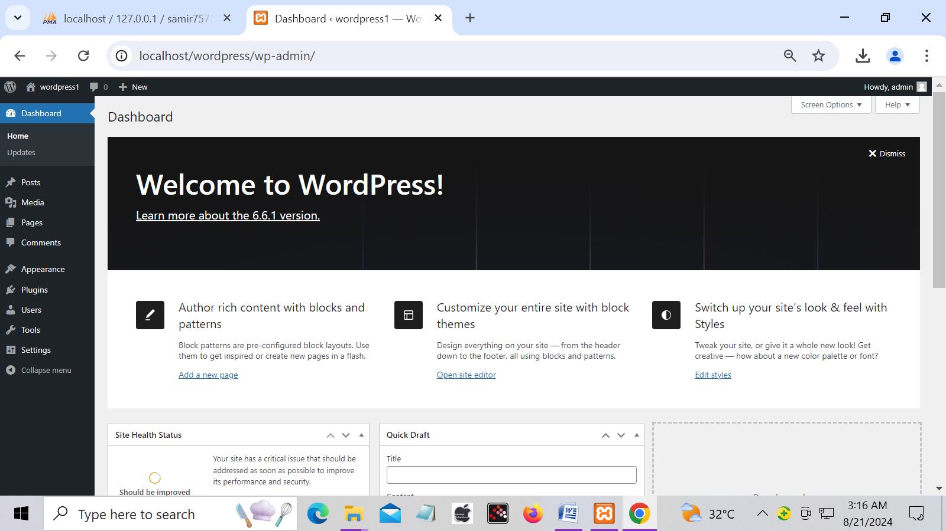

**2.To install and activate theme in wordpress**

**Step 1:- Install wordpress**

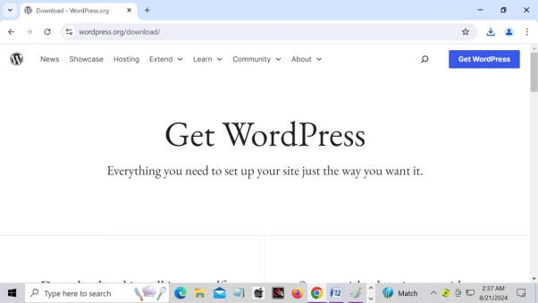

**Step 2:-After install wordpress to login wordpress your id or password.**

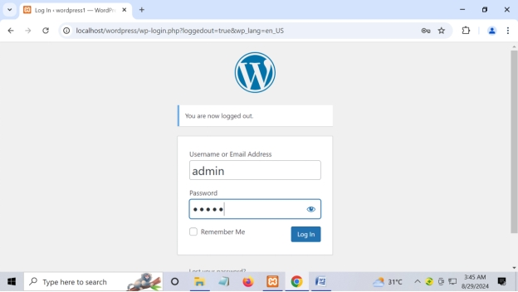

**Step 3:-After login show home page your wordpress.**

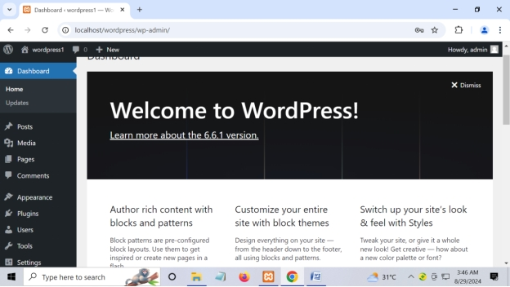

**Step 4:- Click on appearance and select add new theme.**

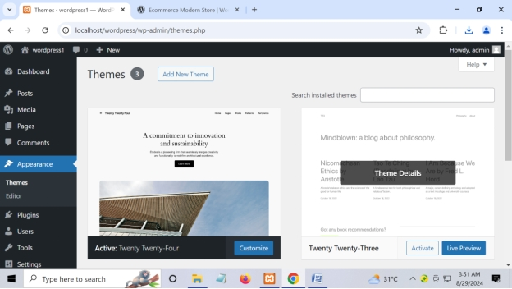

**Step 5:- Click on upload theme**

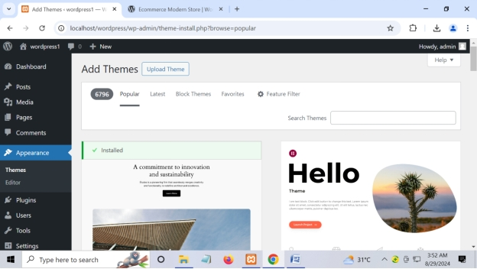

**Step 6:- click on activate and show the selected theme.**

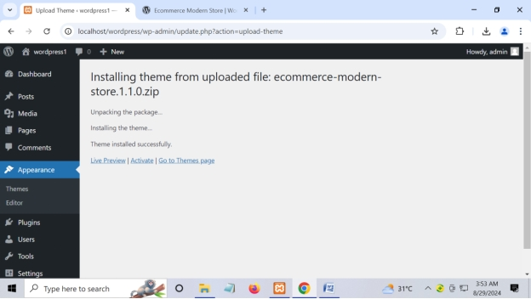

**Step 7:- Show the your selected theme.**

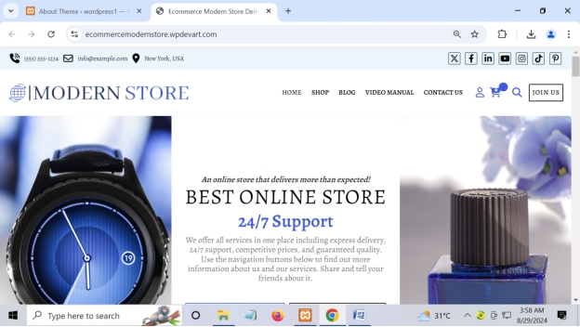

**3.Write a program in WordPress to create a page.**

**Step 1 :- Click on page option**

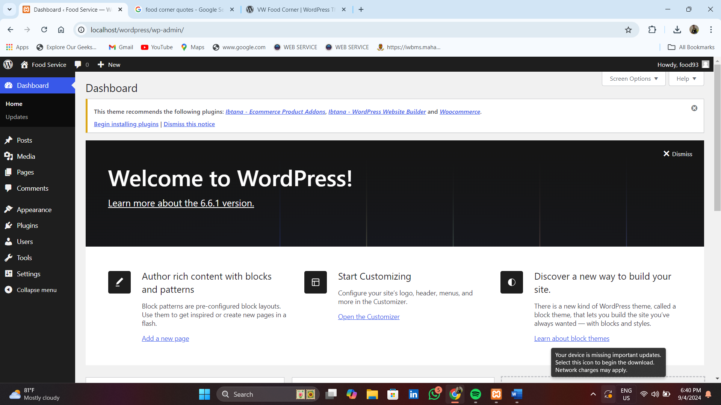

**Step 2 :- Select all page**

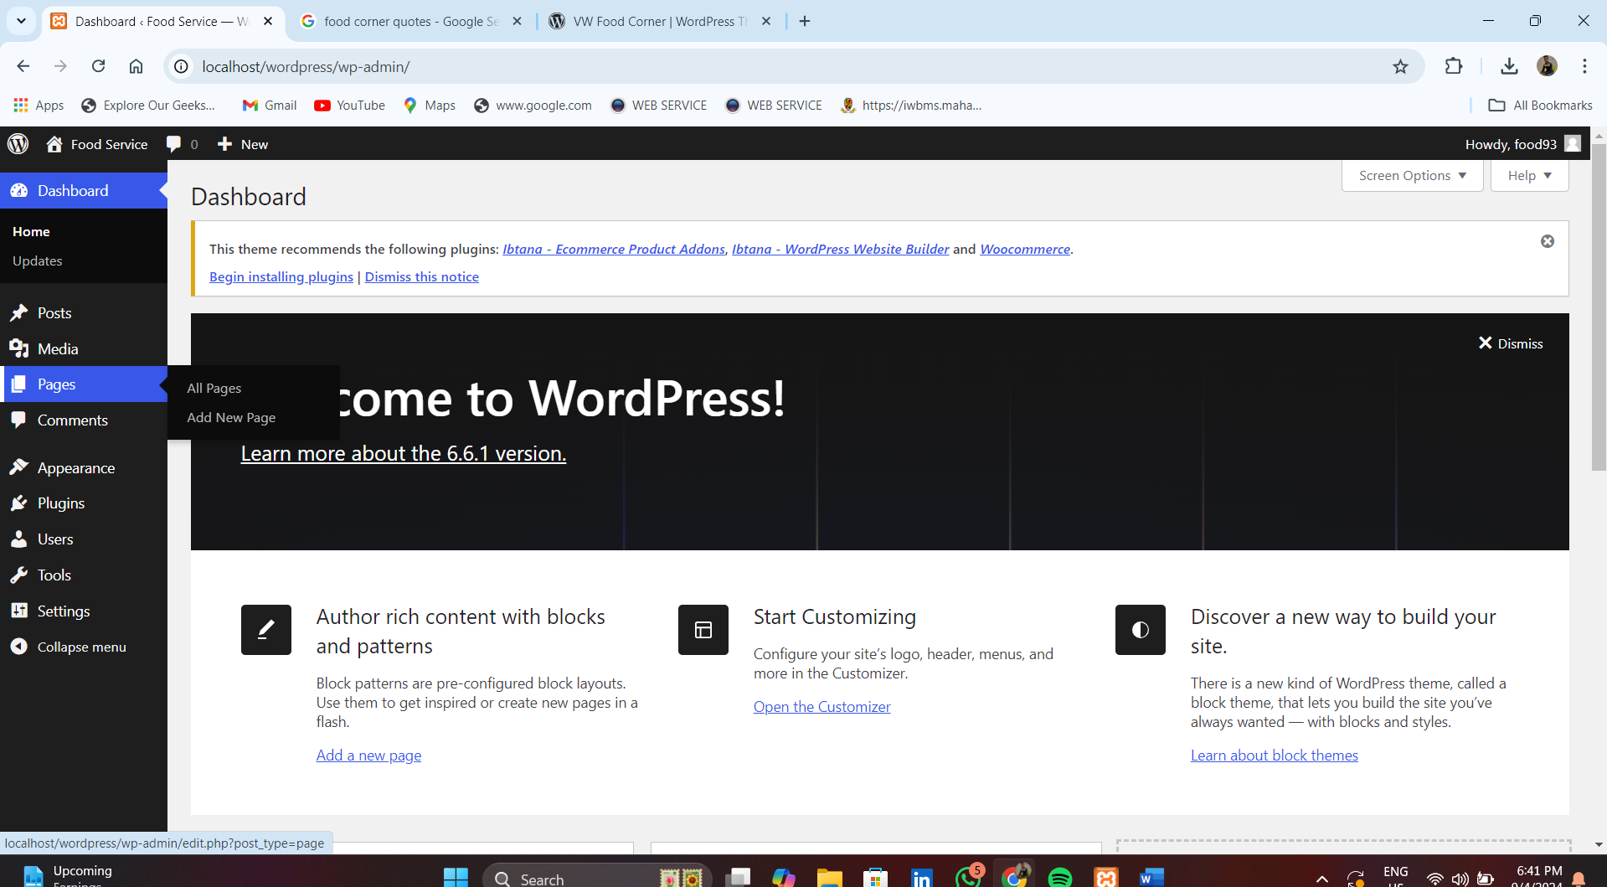

**Step 3:- Click on add new page.**

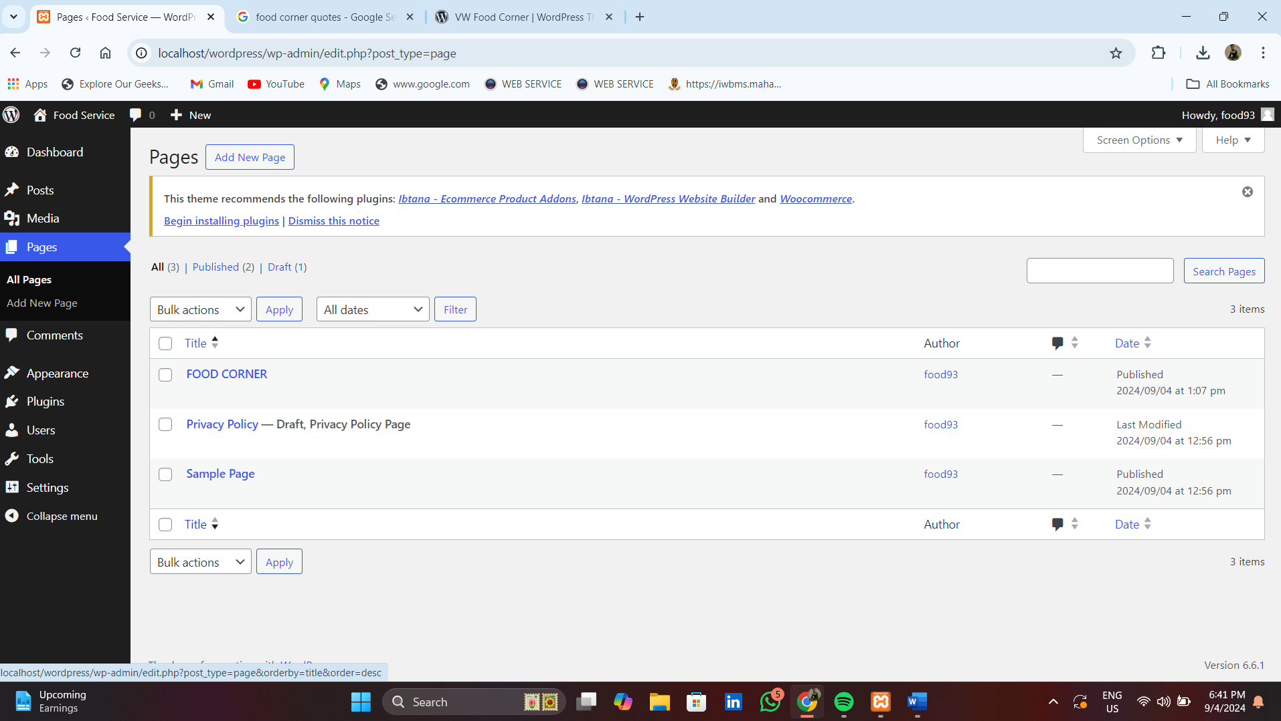

**Step 4:- Set to title and block and set image or click on publish.**

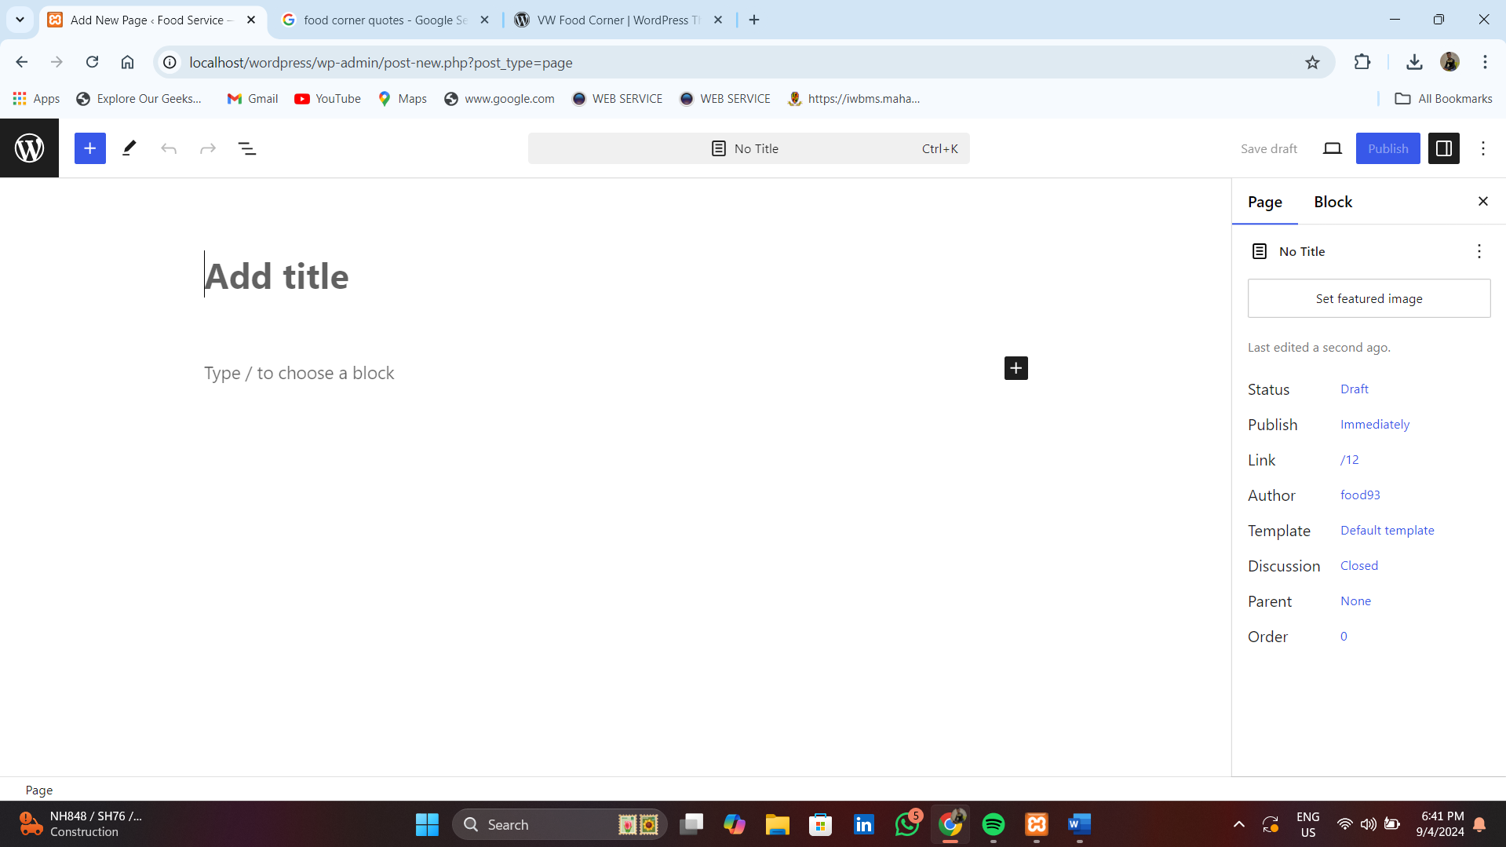

**Step 5 :- After publish title view page.**

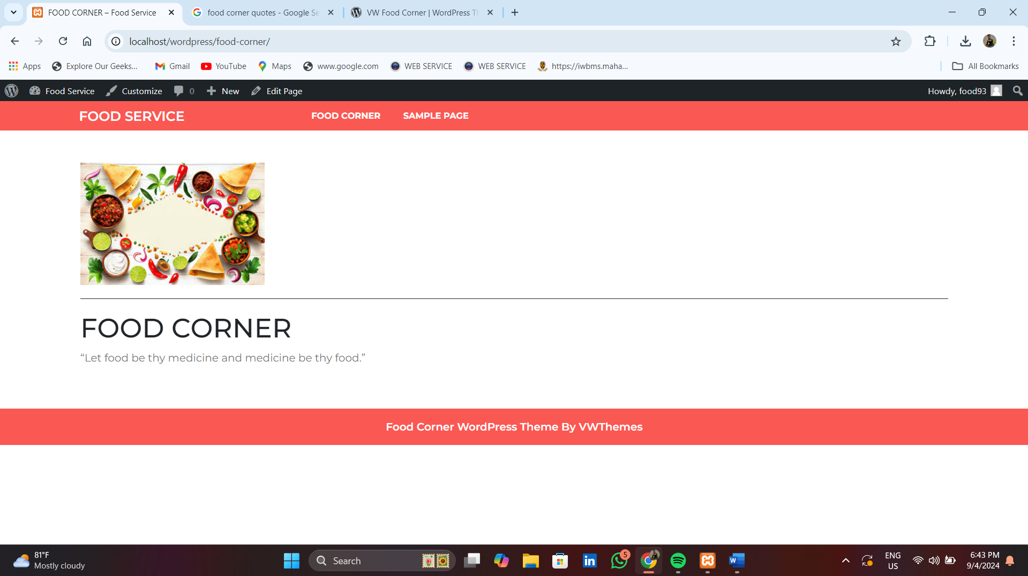

**4.Write a program in wordpress to create a Blog**.

**Step 1:- click on posts**

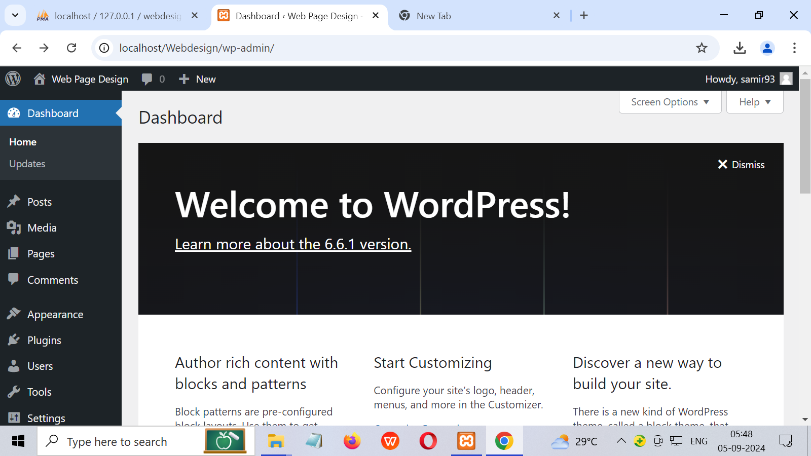

**Step 2:- After clicking posts to next click all post**

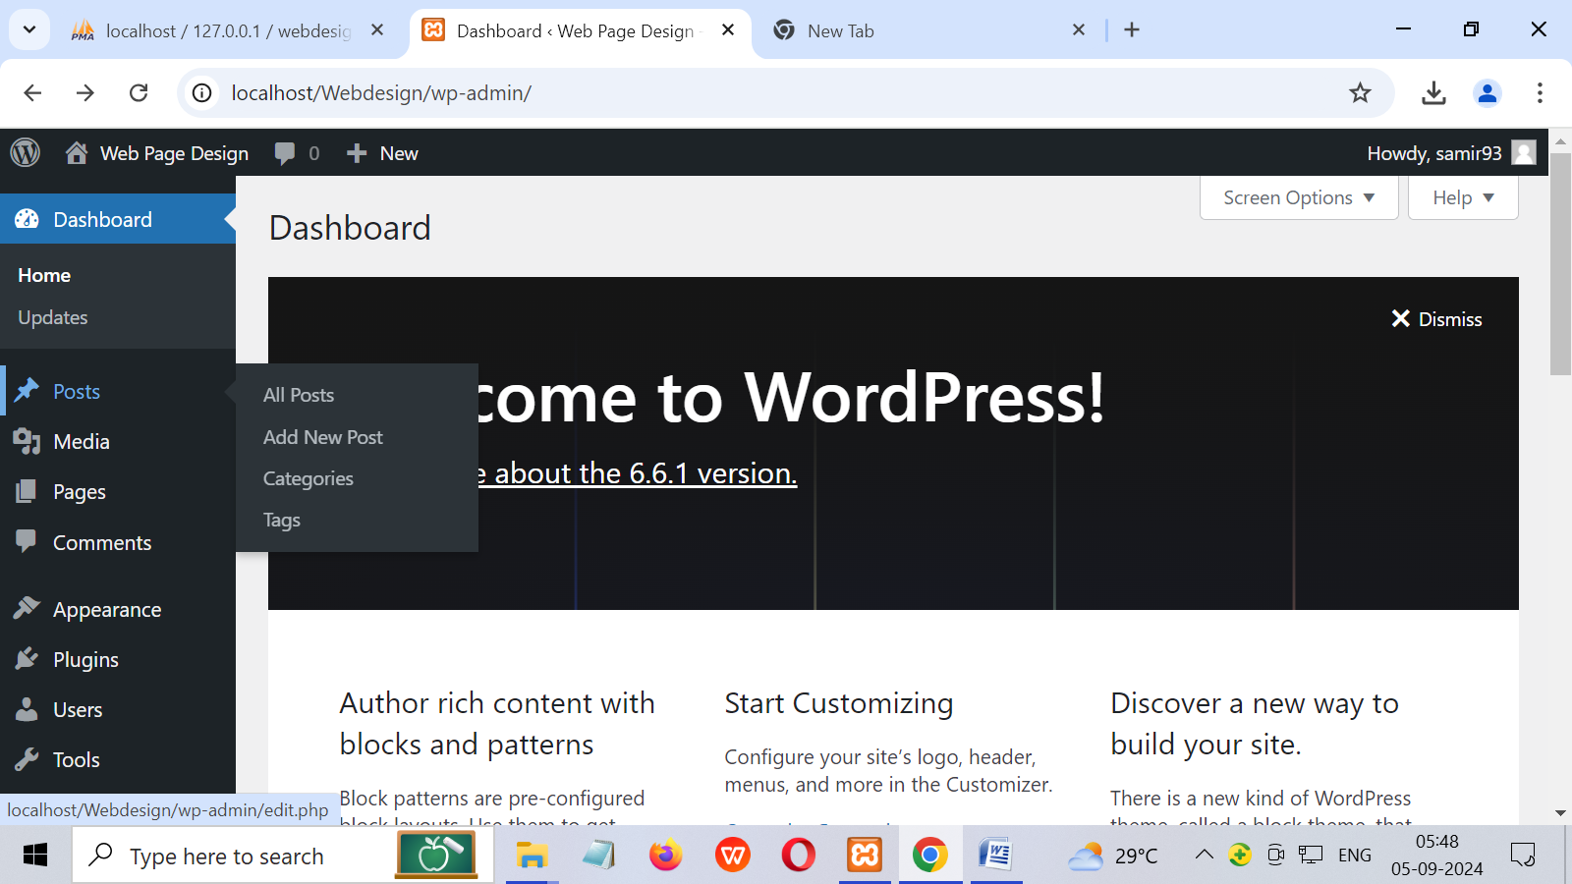

**Step 3:- Select the add new post**

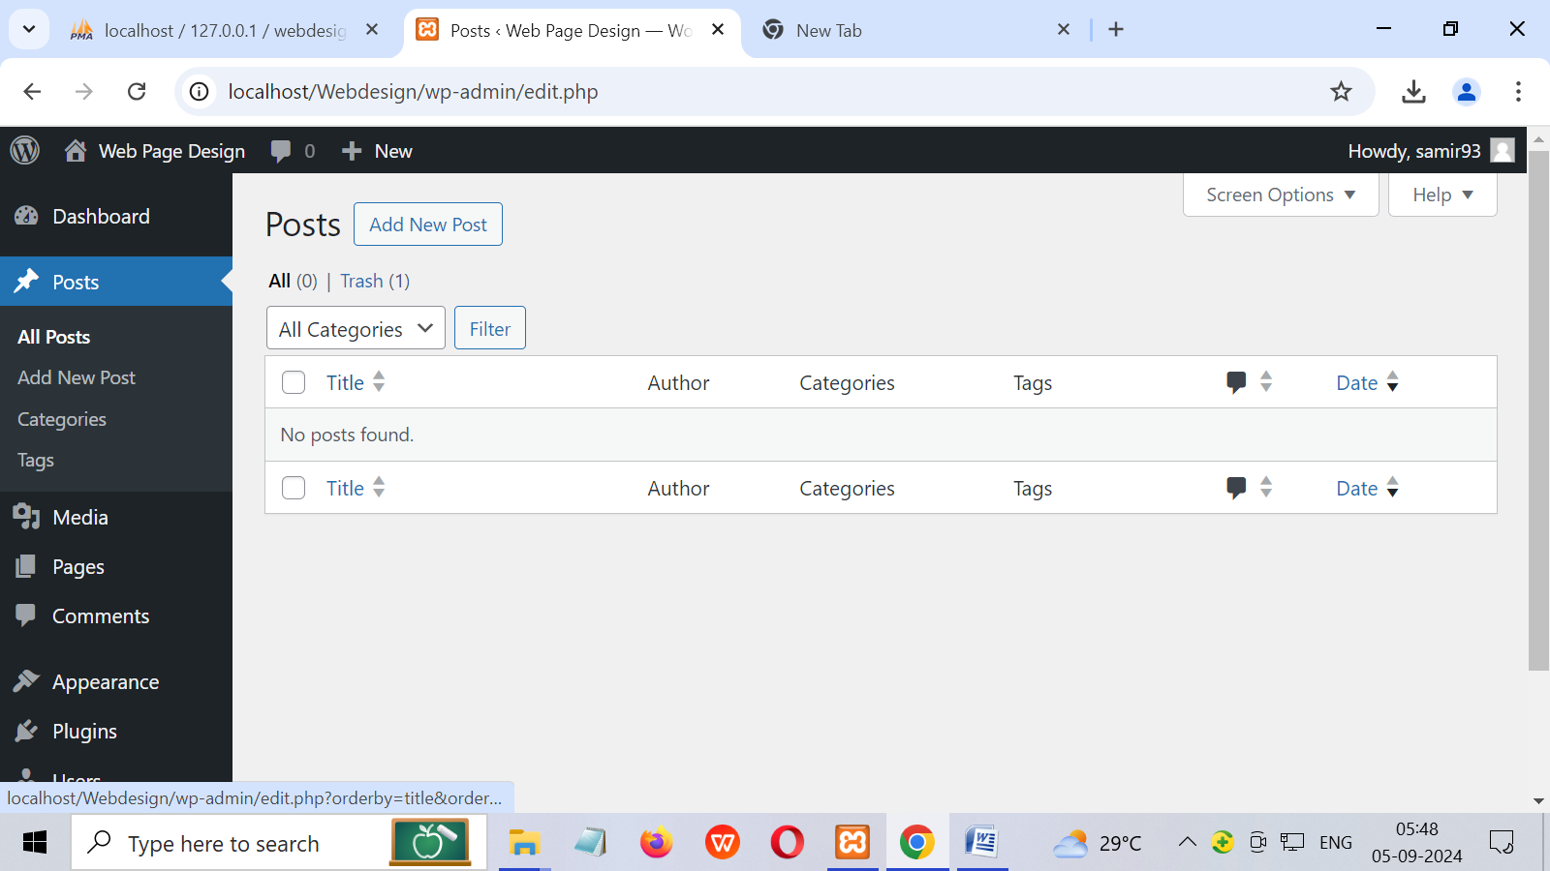

**Step 4 :- After add new post select to create post and mentions categories or publish post.**

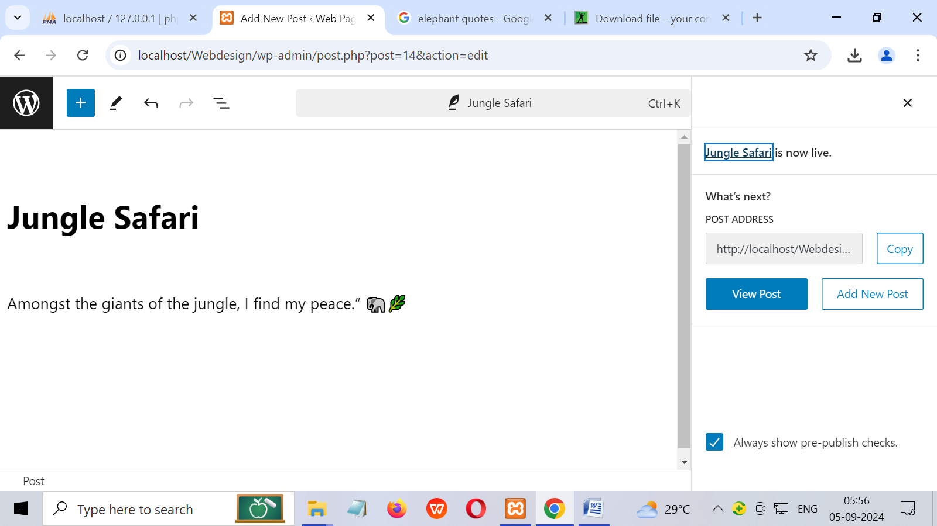

**Step 5 :- After publishing post to show post one by one in your dashboard.**

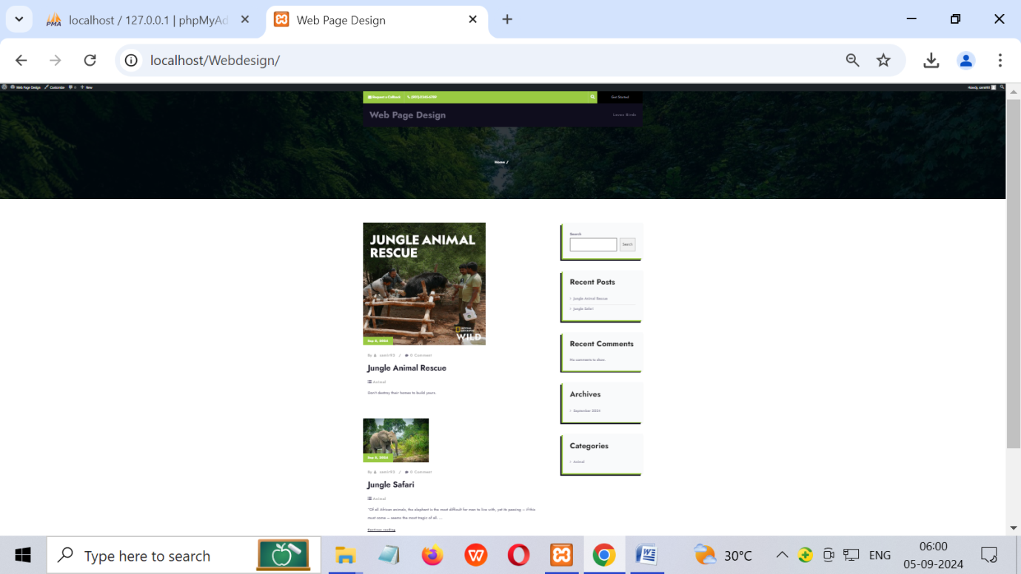

**5.Write a program in wordpress to create a slider.(Using smart slider plugin).**

**Step:1 open the wordpress and click on plugin**

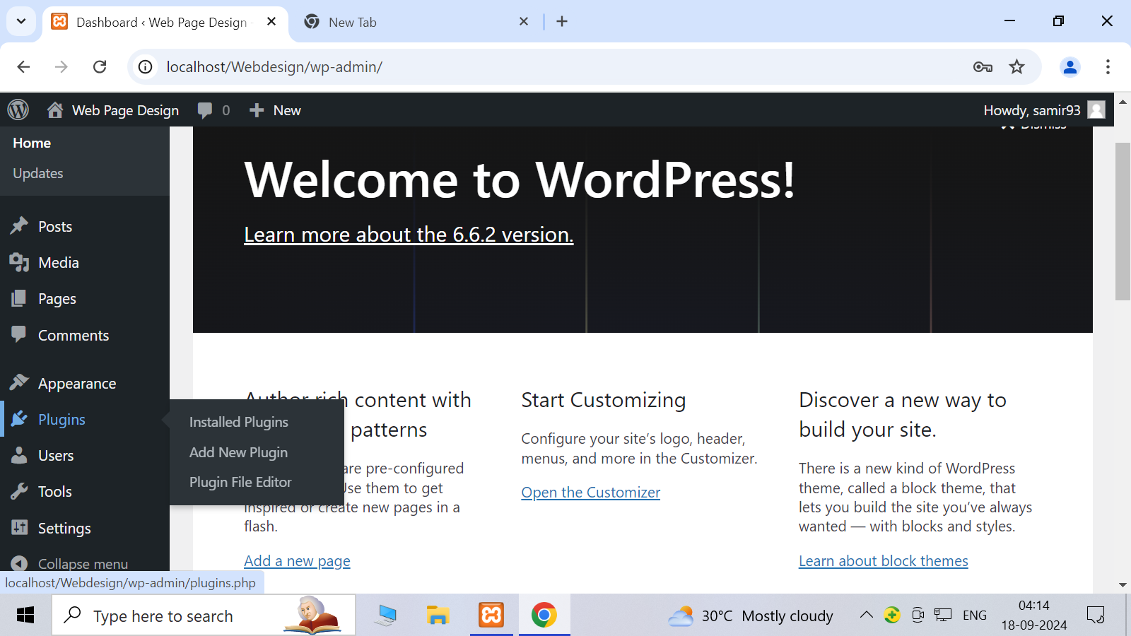

**Step:2 click on search plugin and download smart slider**

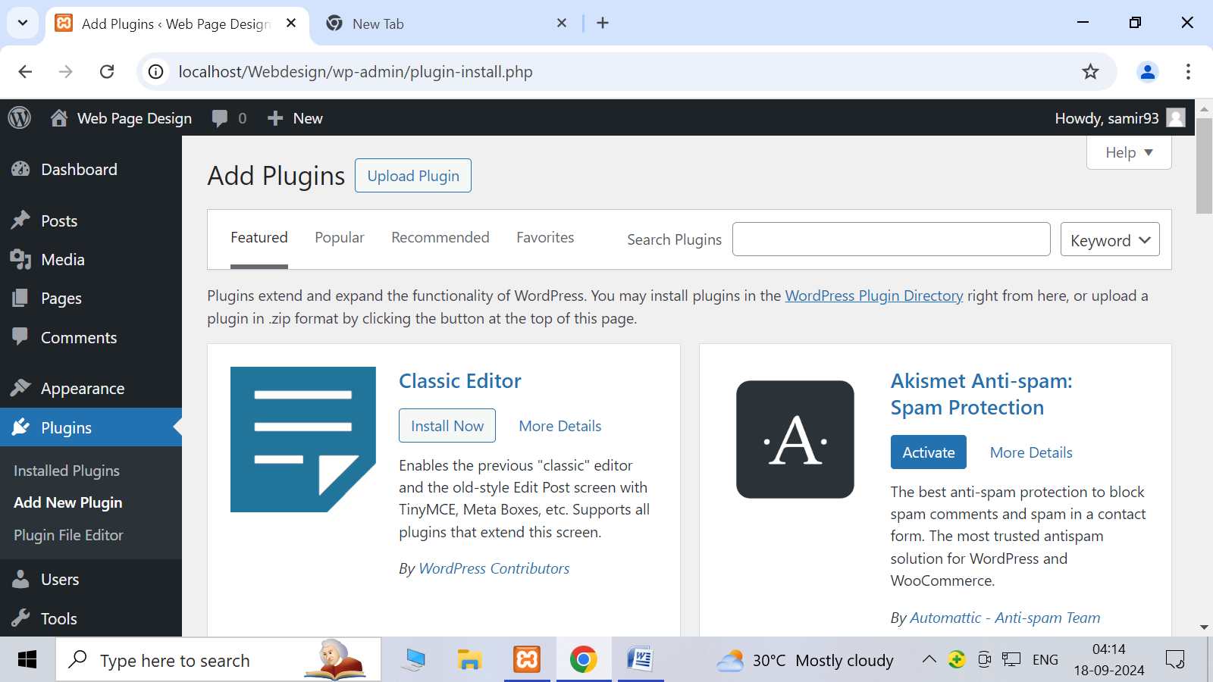

**Step:3 click on smartslider**

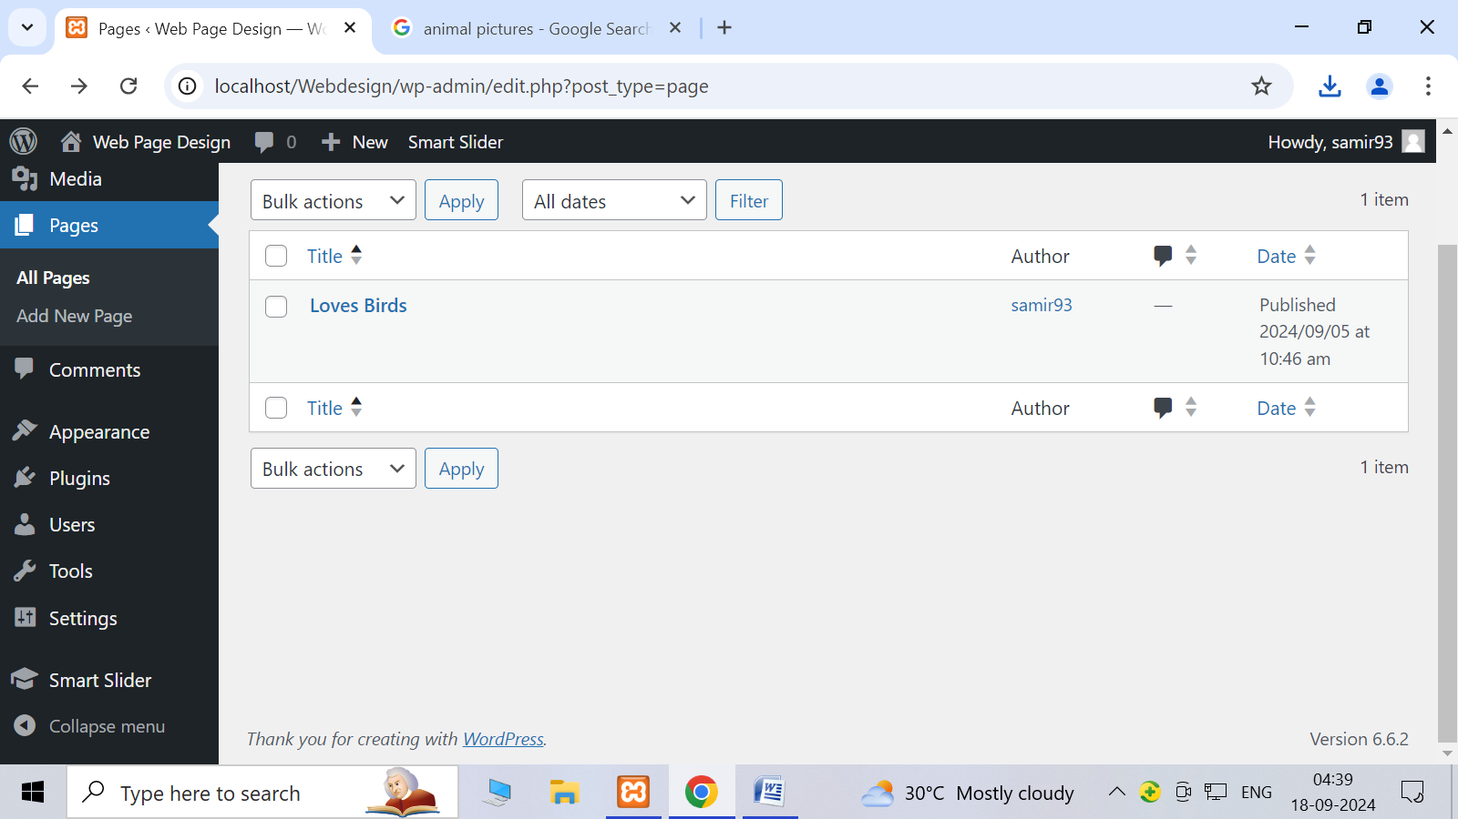

**Step:4 go to dashboard for smart slider**

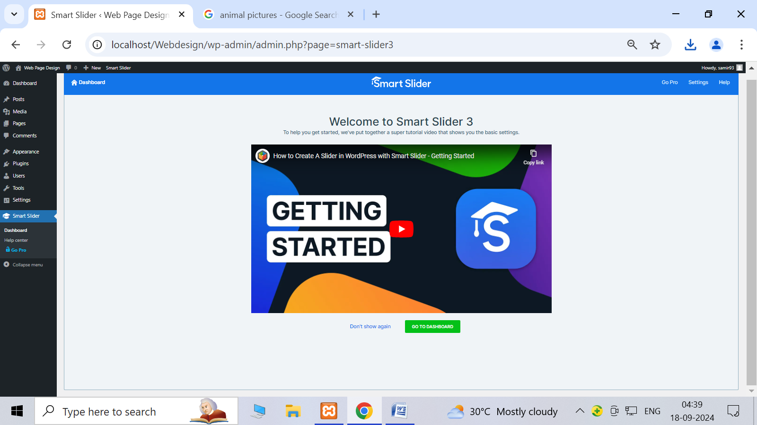

**Step:-5 click on new project and create new project**

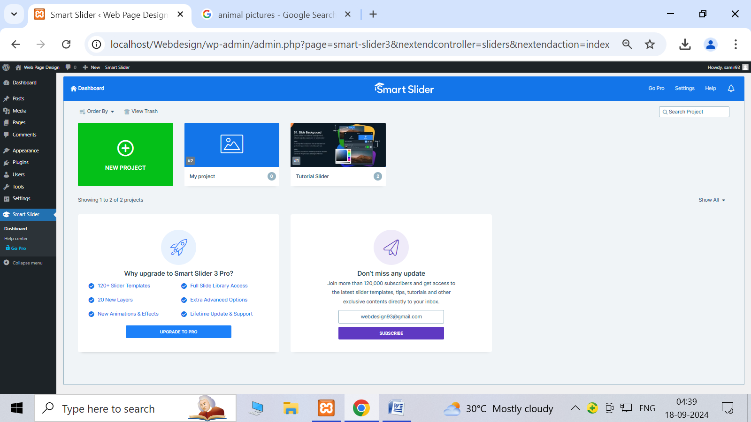

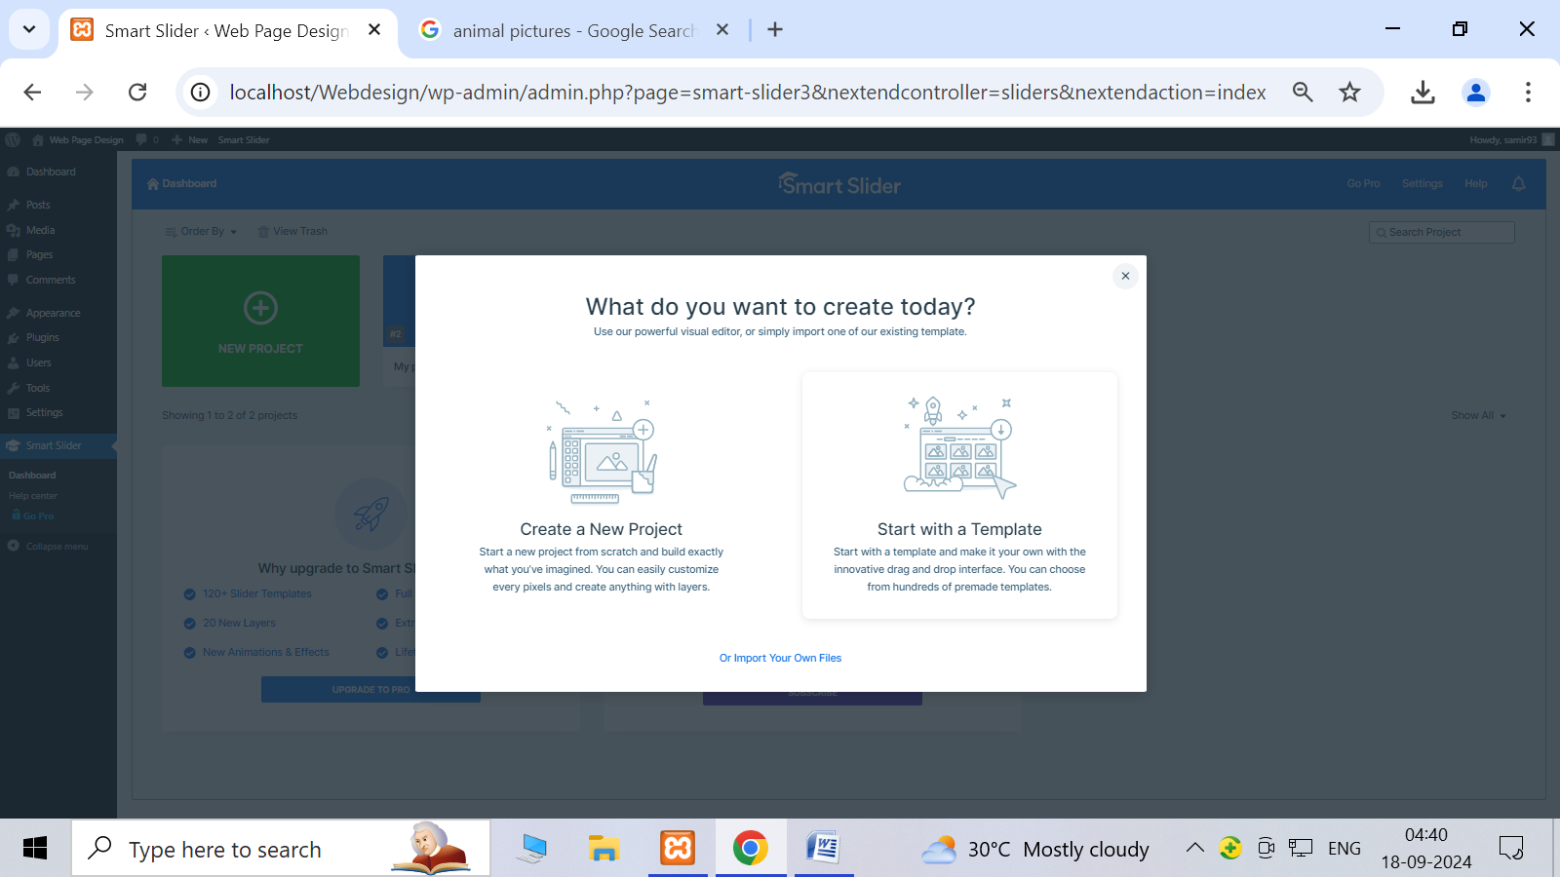

**Step:-6 choose project type and create project name**

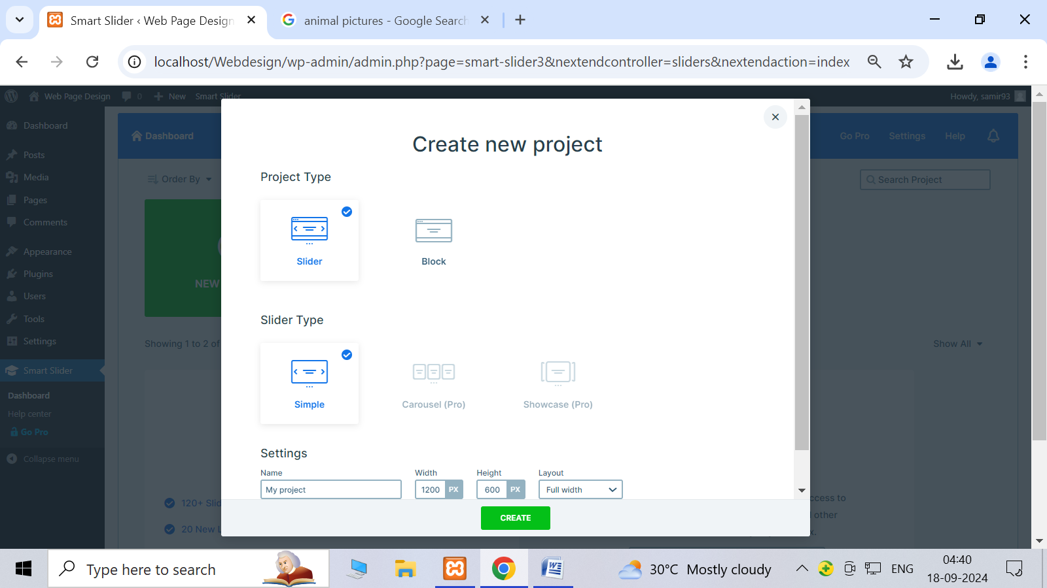

**Step:7 Add new slide and select the image**

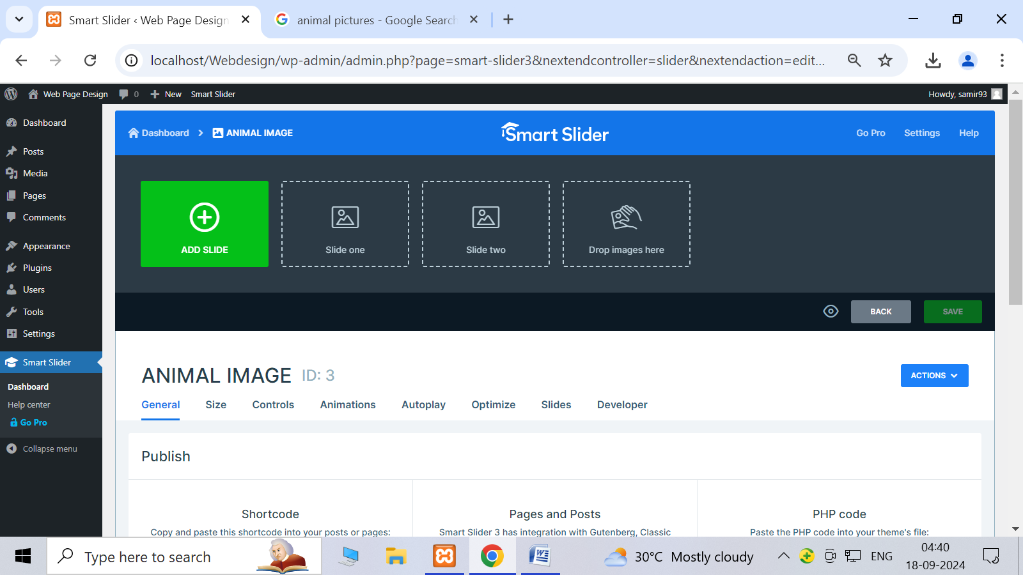

**Step:-8 Show the slide our site page.**

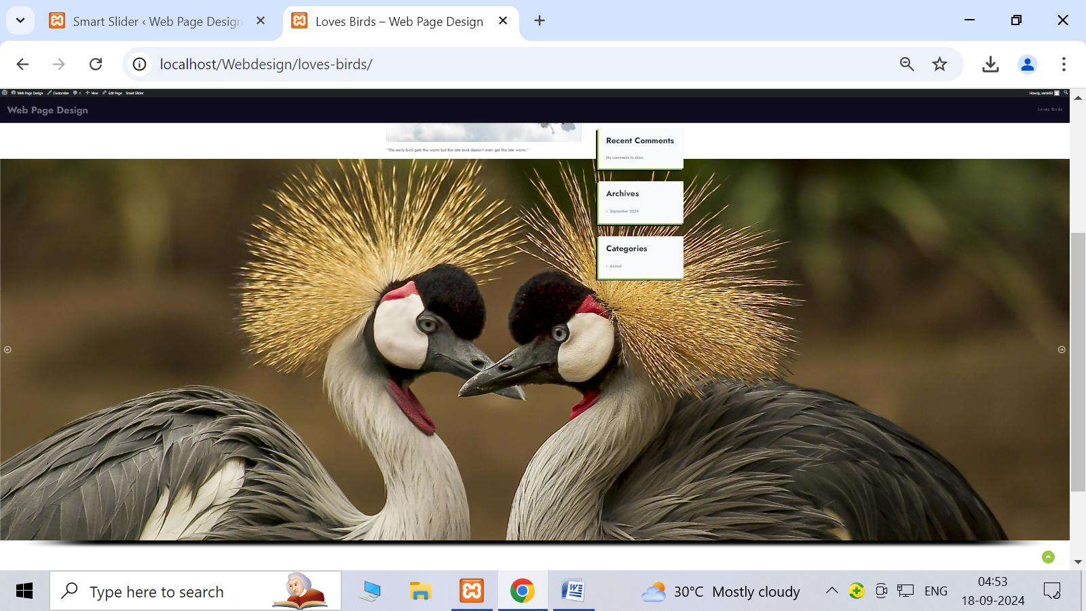

**6.Perform process of installation of Joomla.**

Step:1 Download the joomla

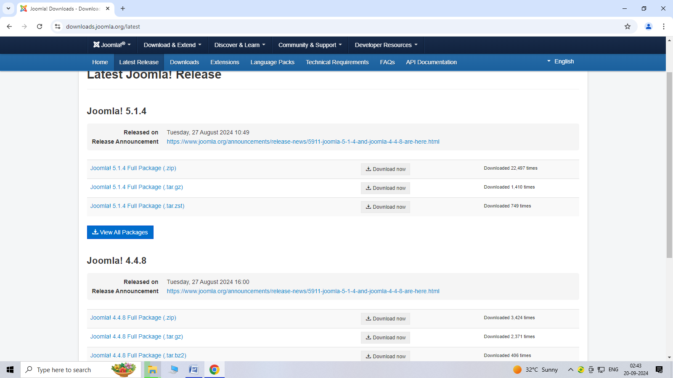

Step:-2 After download start xampp server.

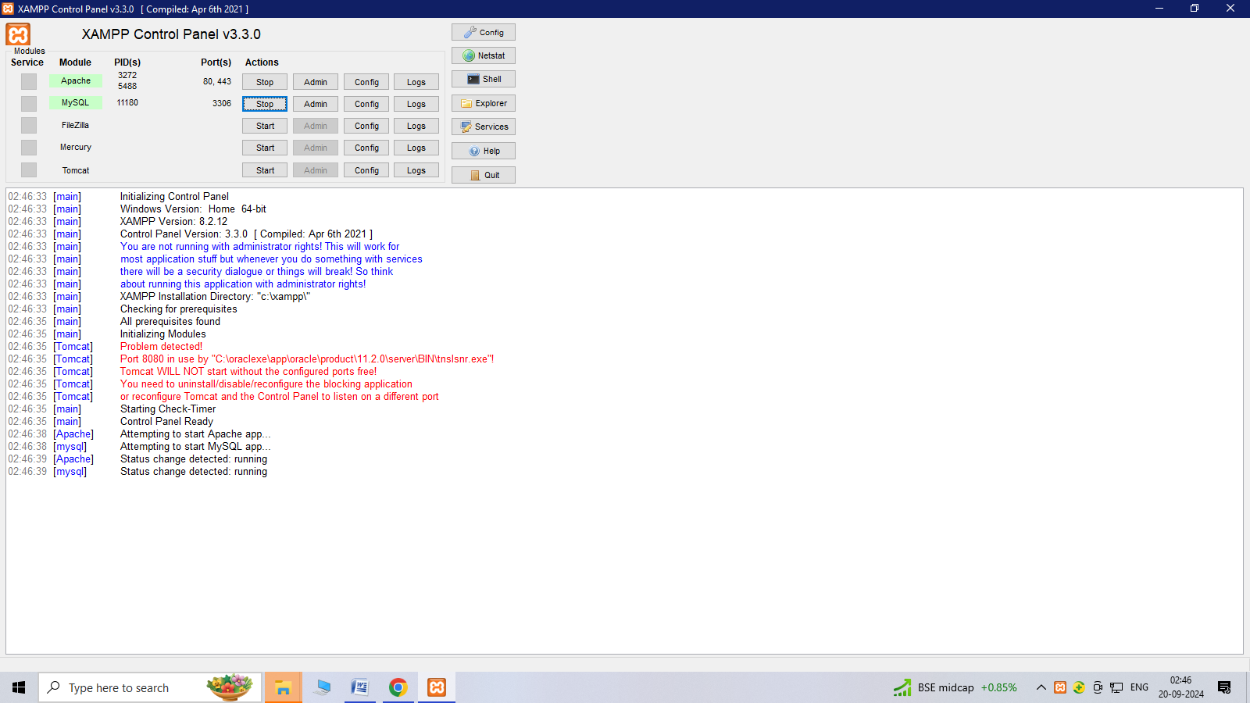

Step:3 create site name

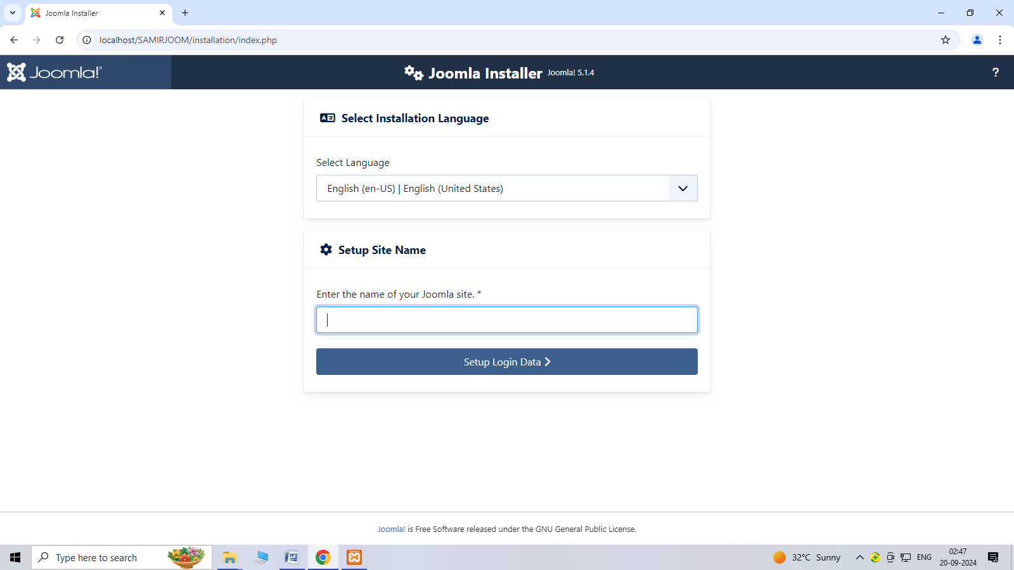

Step:4 create username and password

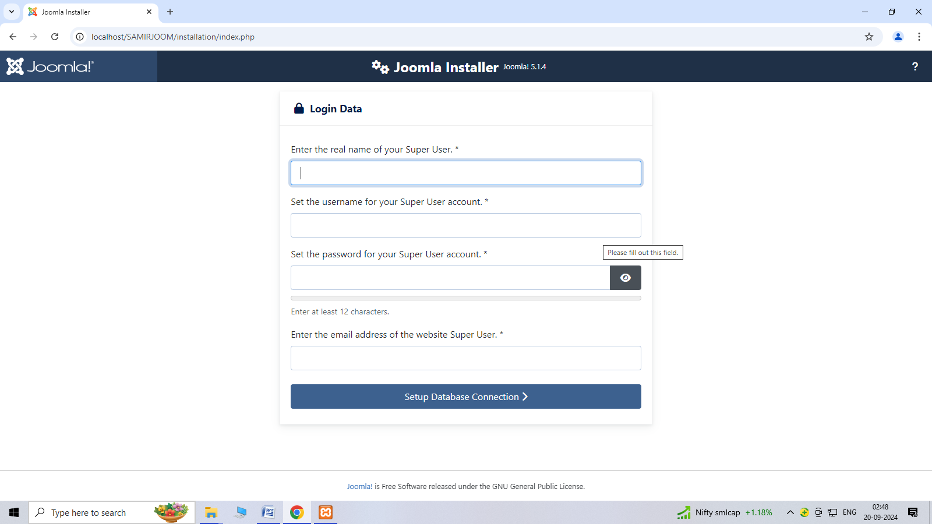

Step:5 connect to database

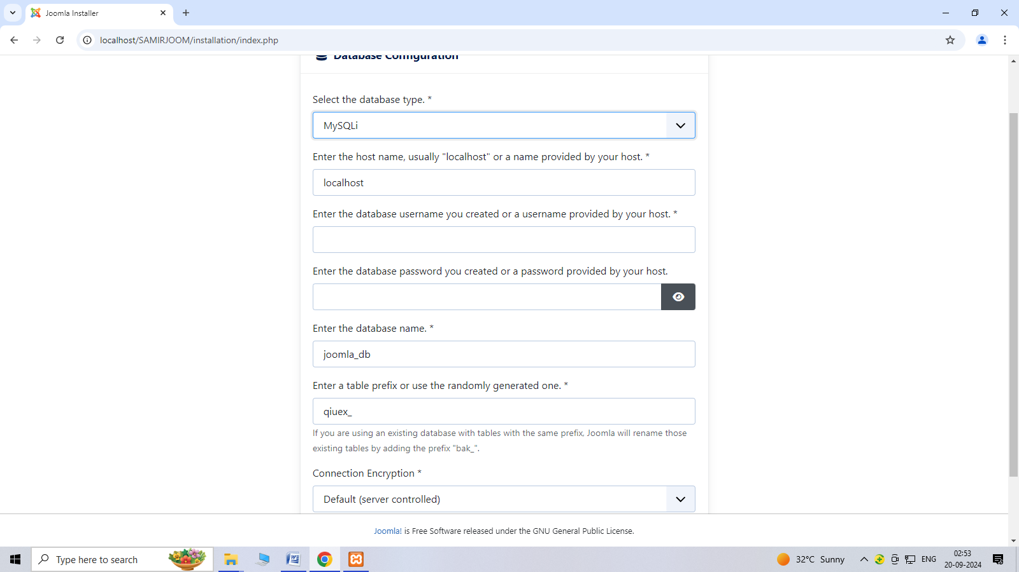

Step:6 After database process installation is start.

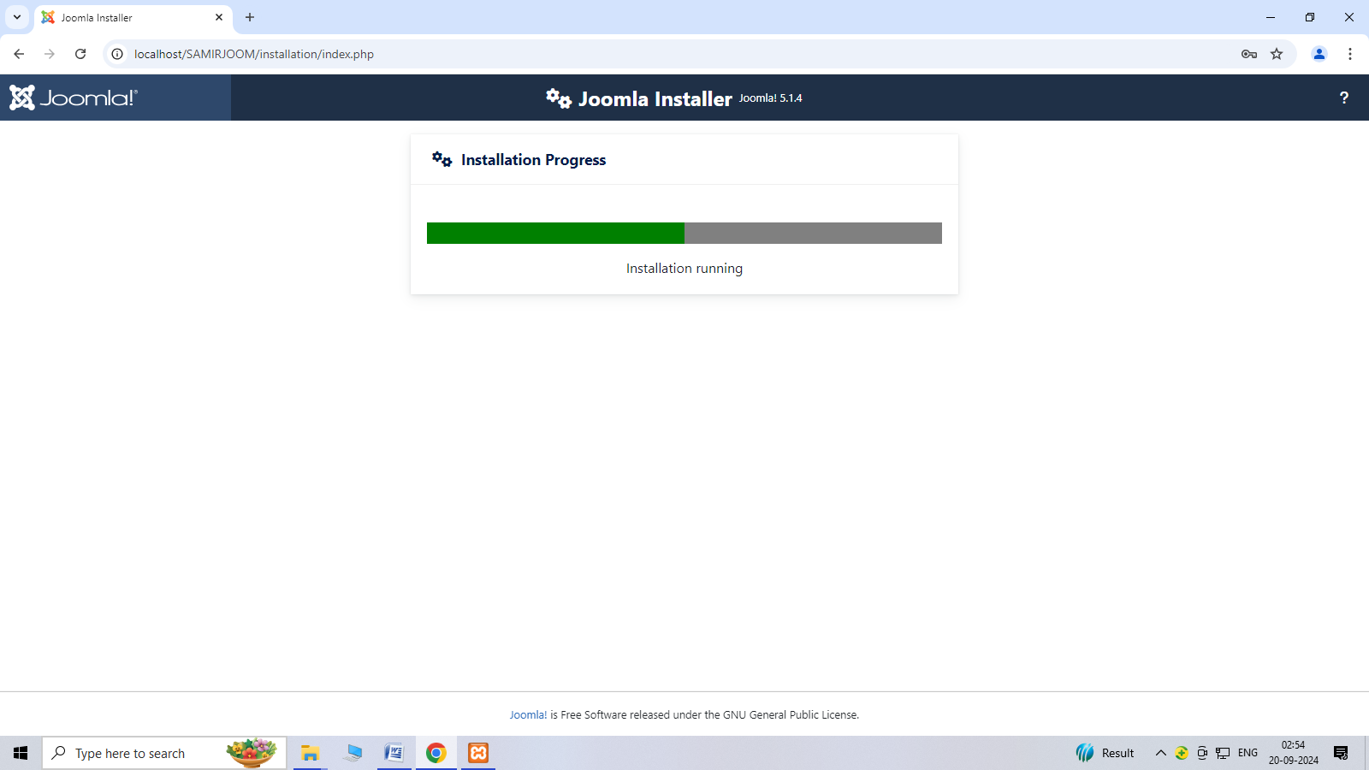

Step:7 After installation click on open administrator.

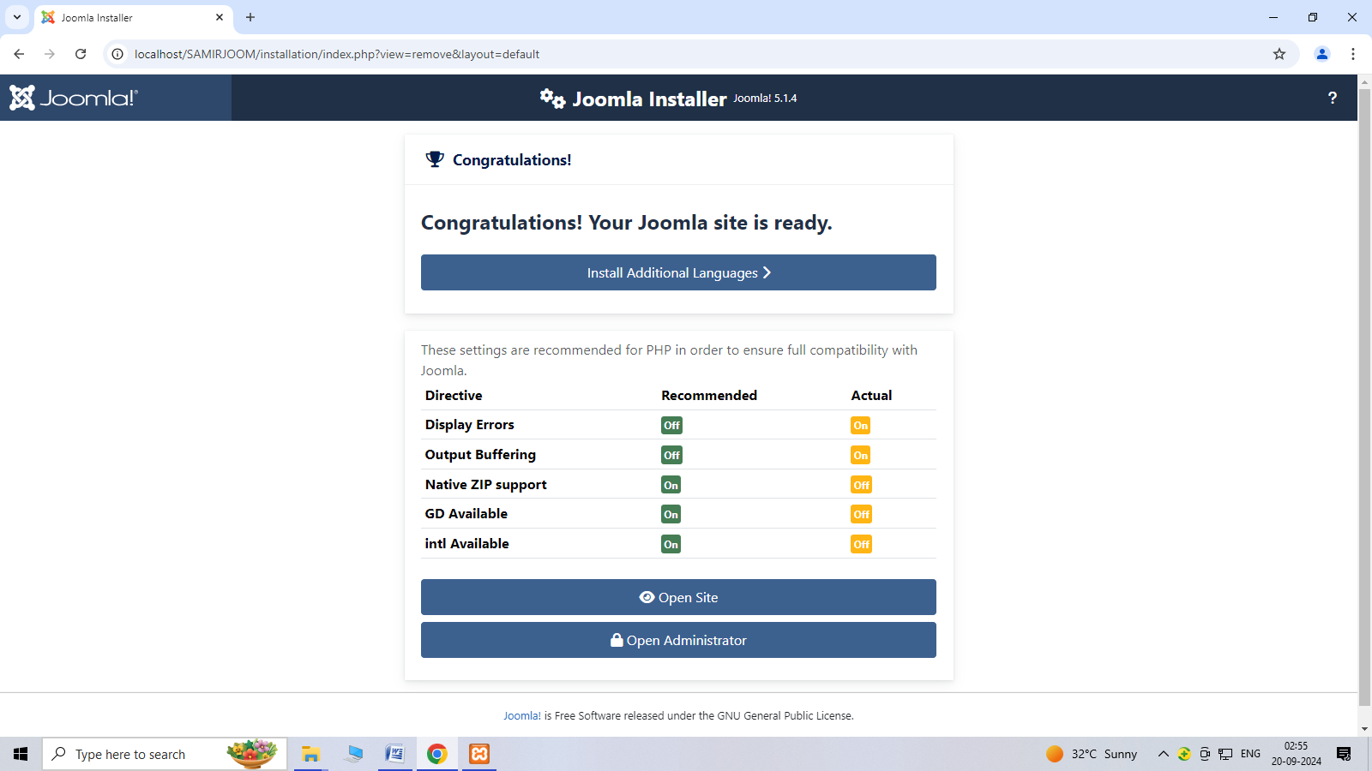

Step:8 login joomla home page.

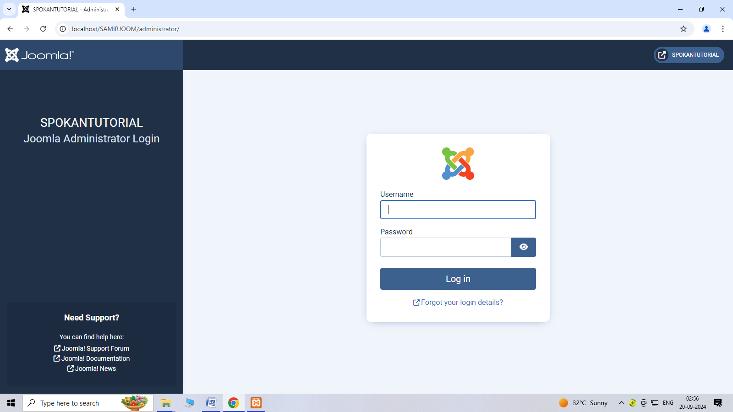

Step:9 After login joomla dashboard show.

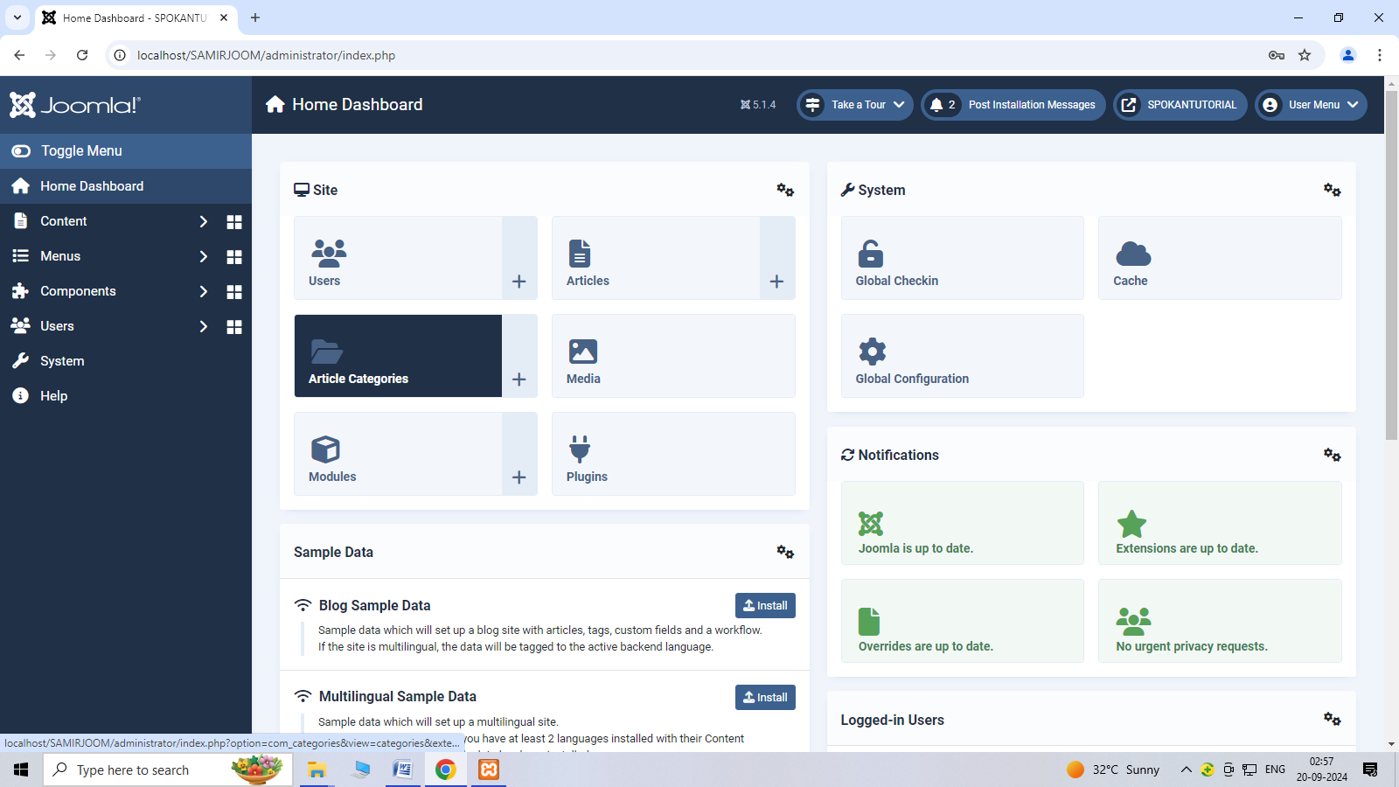

**7.WAP in joomla to change templates styles(site).**

Step 1:- Login to joomla

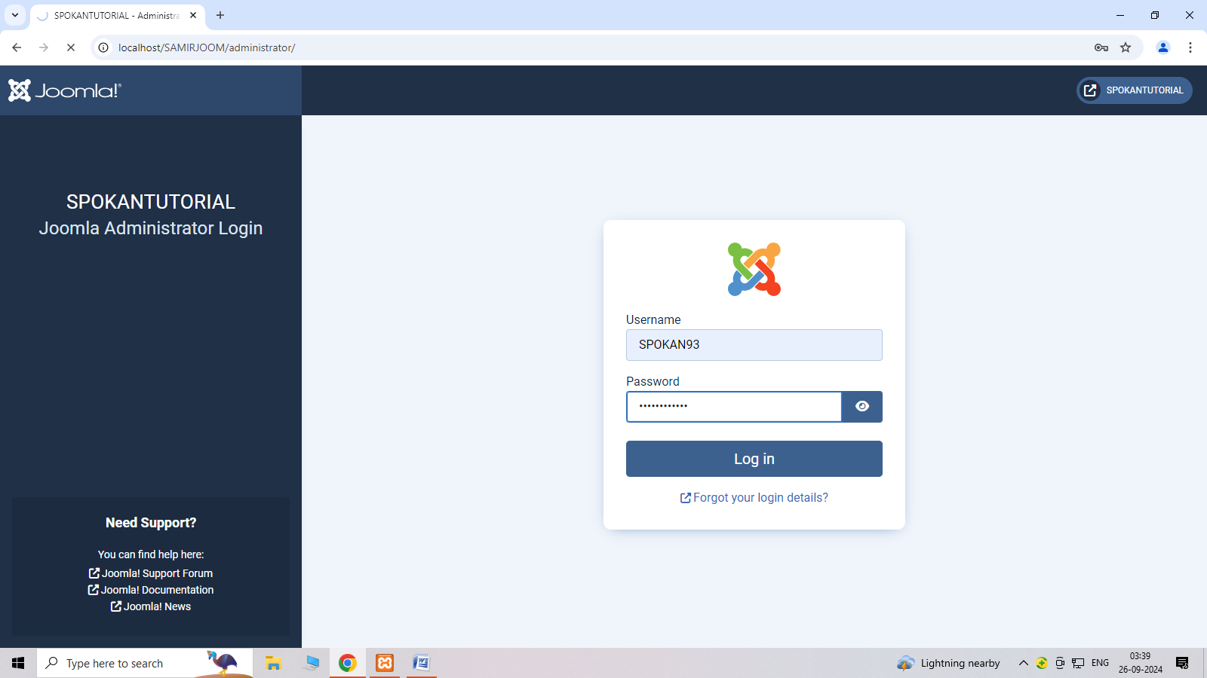

Step 2 :- click on system and select extensions

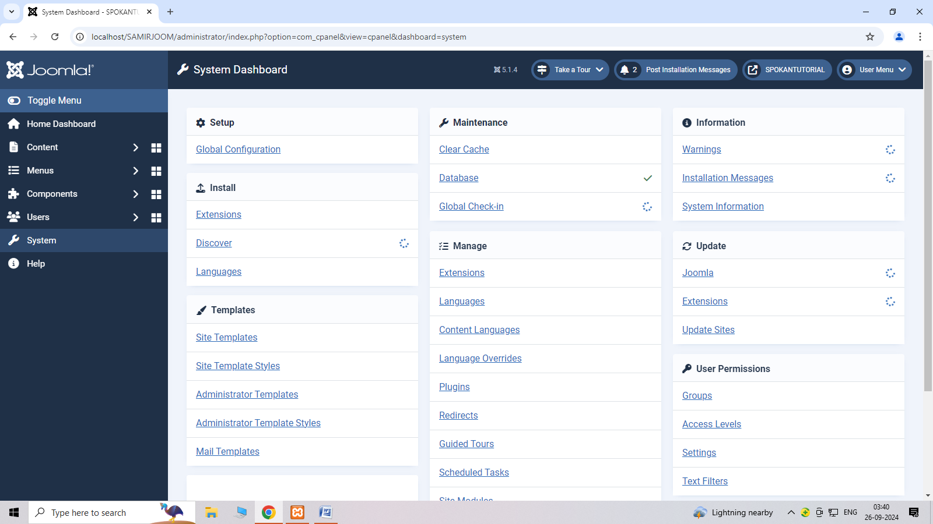

Step 3:- Add new plugin.

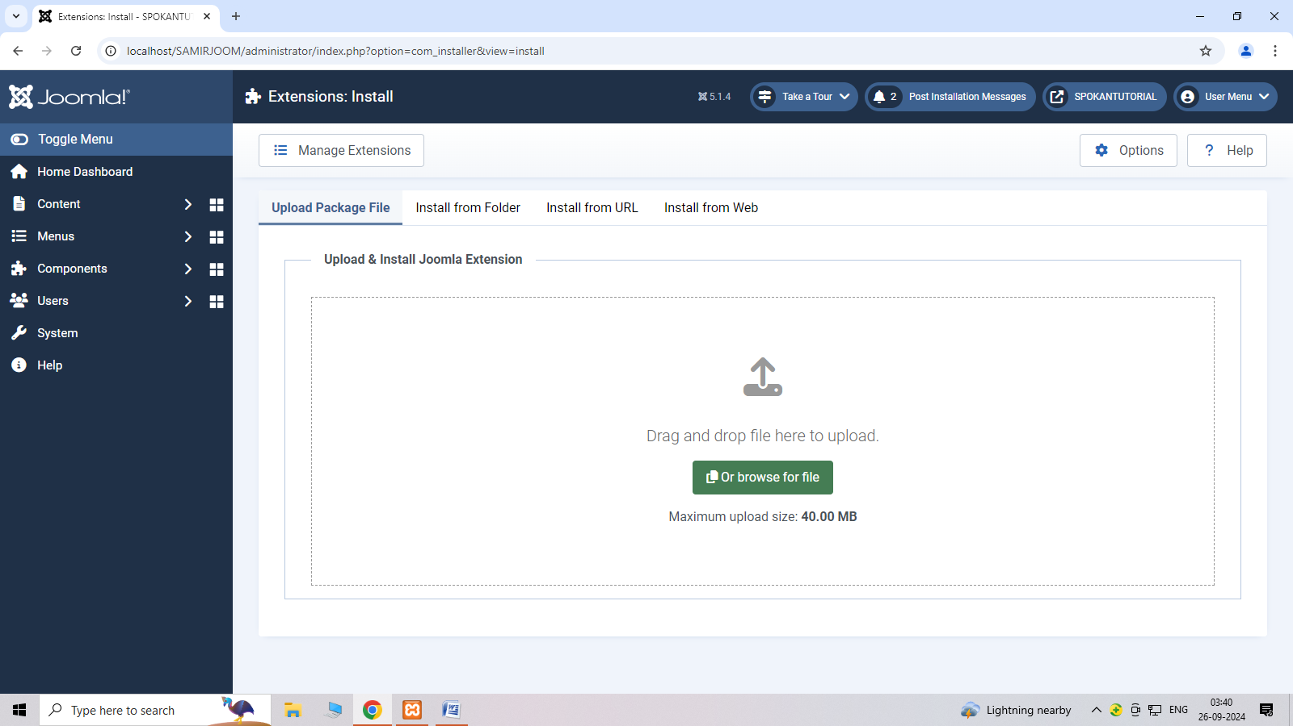

Step 4: After add new plugin click on template styles.

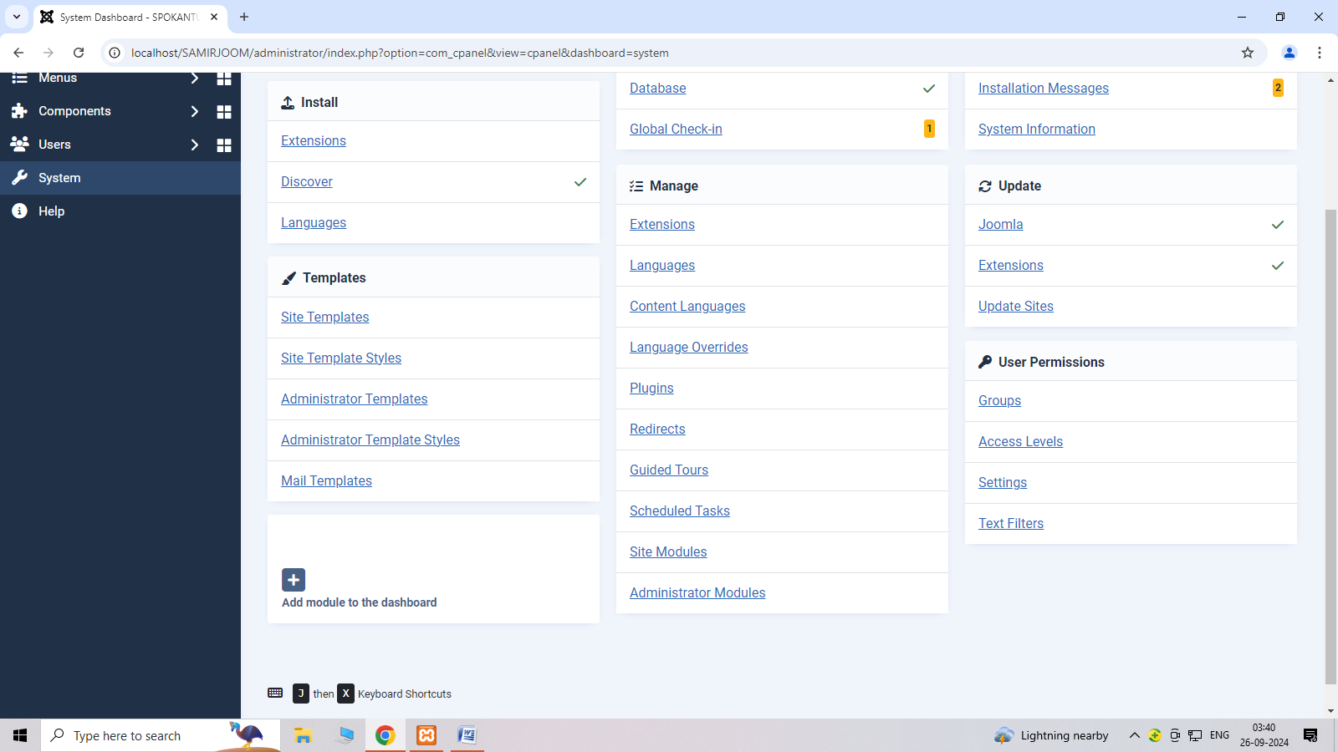

Step 5:- Activate New template.

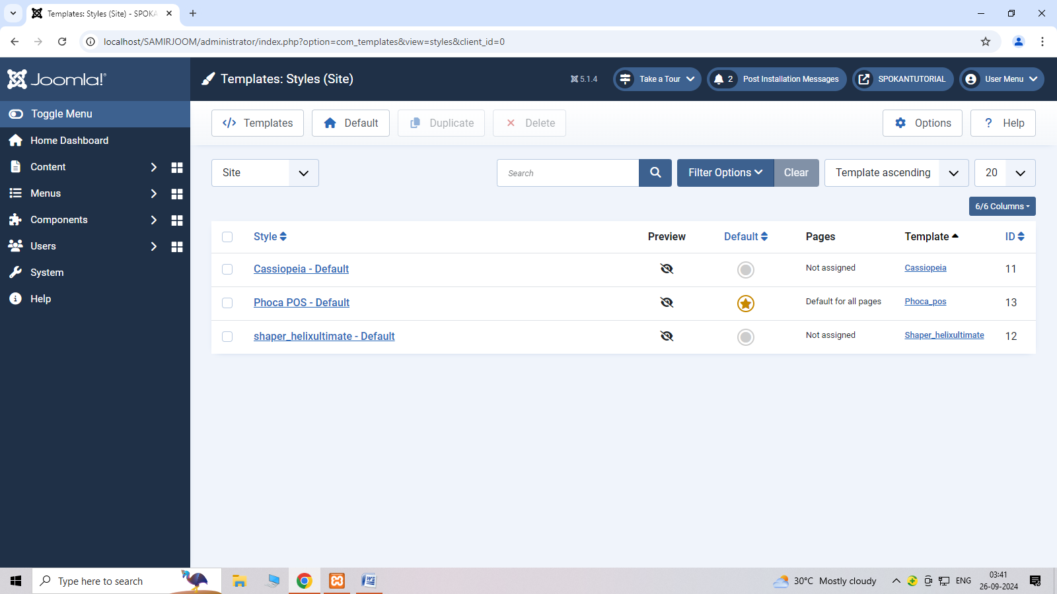

Step 6:- Show new template.

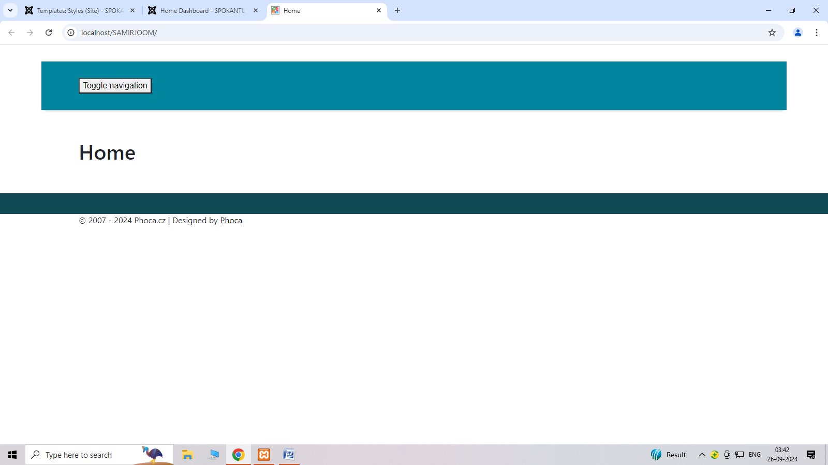

**8.WAP in joomla to create menus.**

**Step 1 click on menus.**

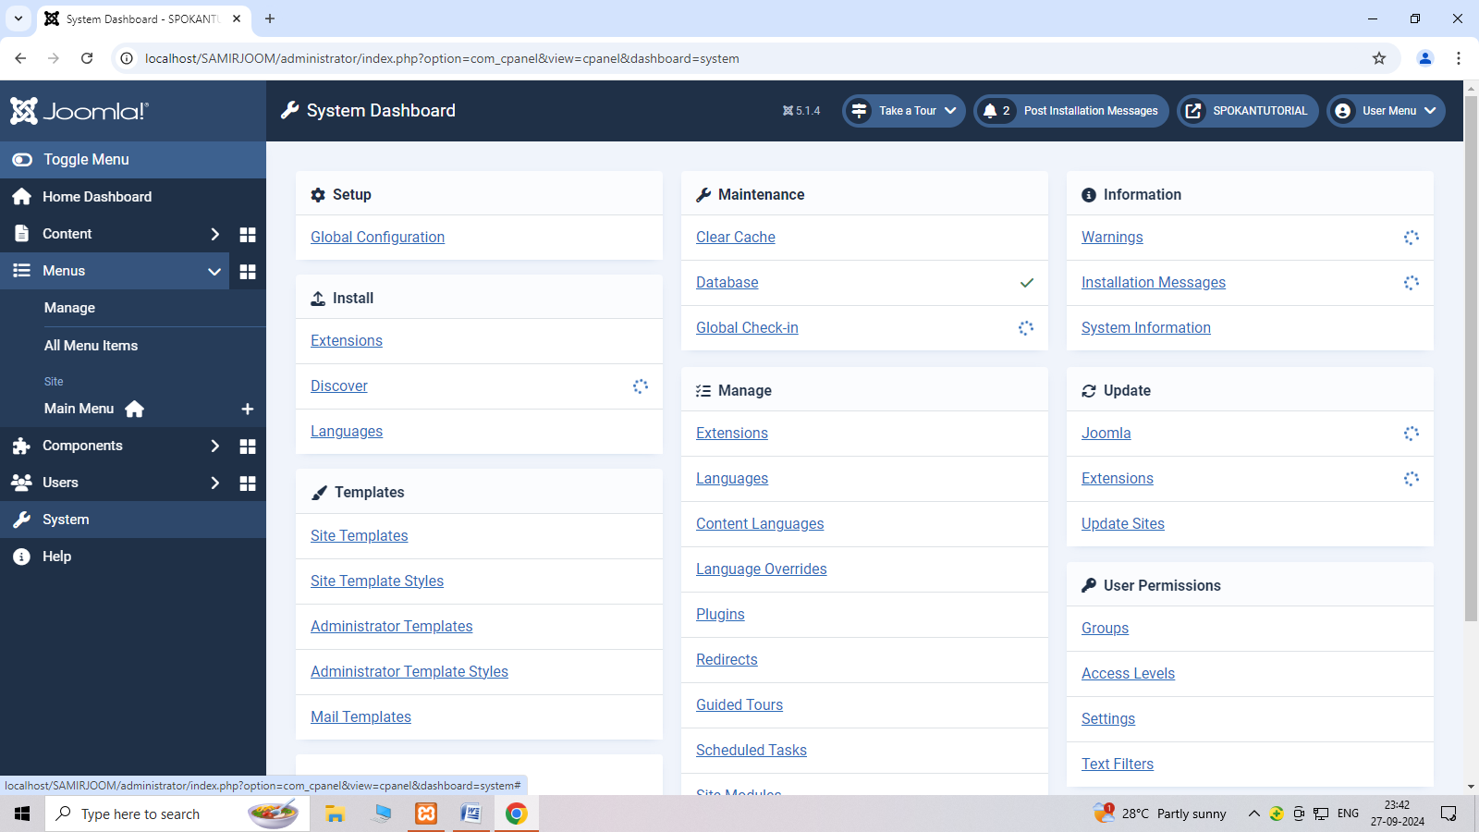

**Step2: add menu**

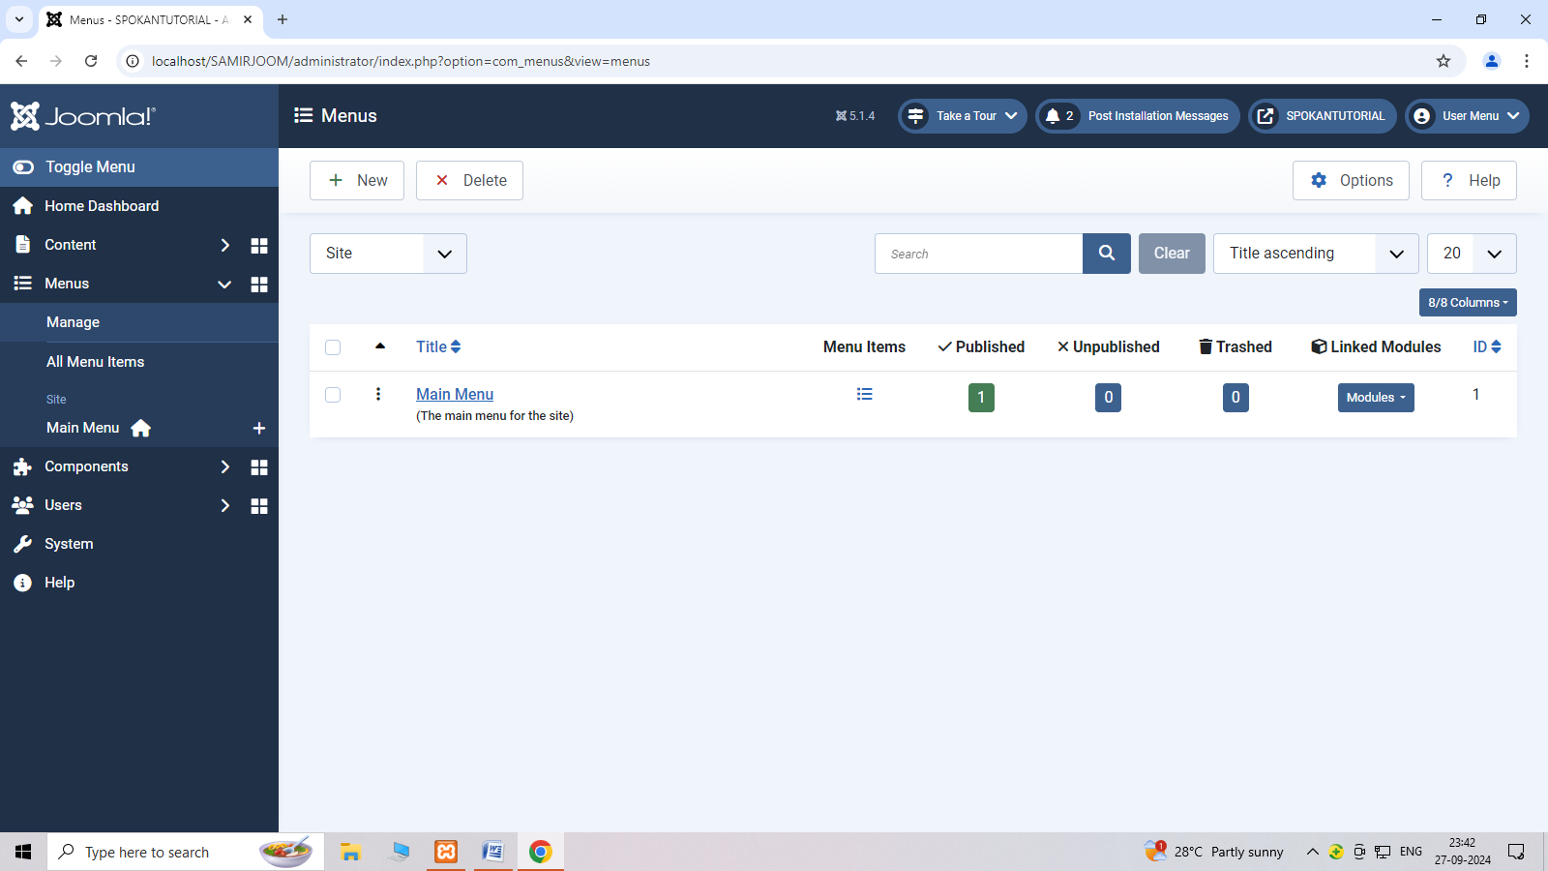

**Step 3: create menu**

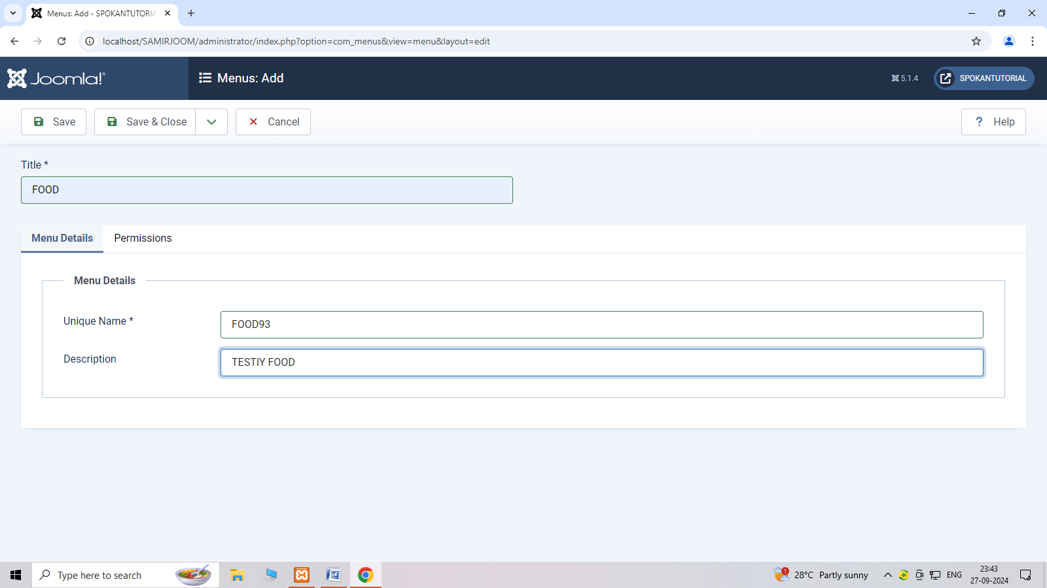

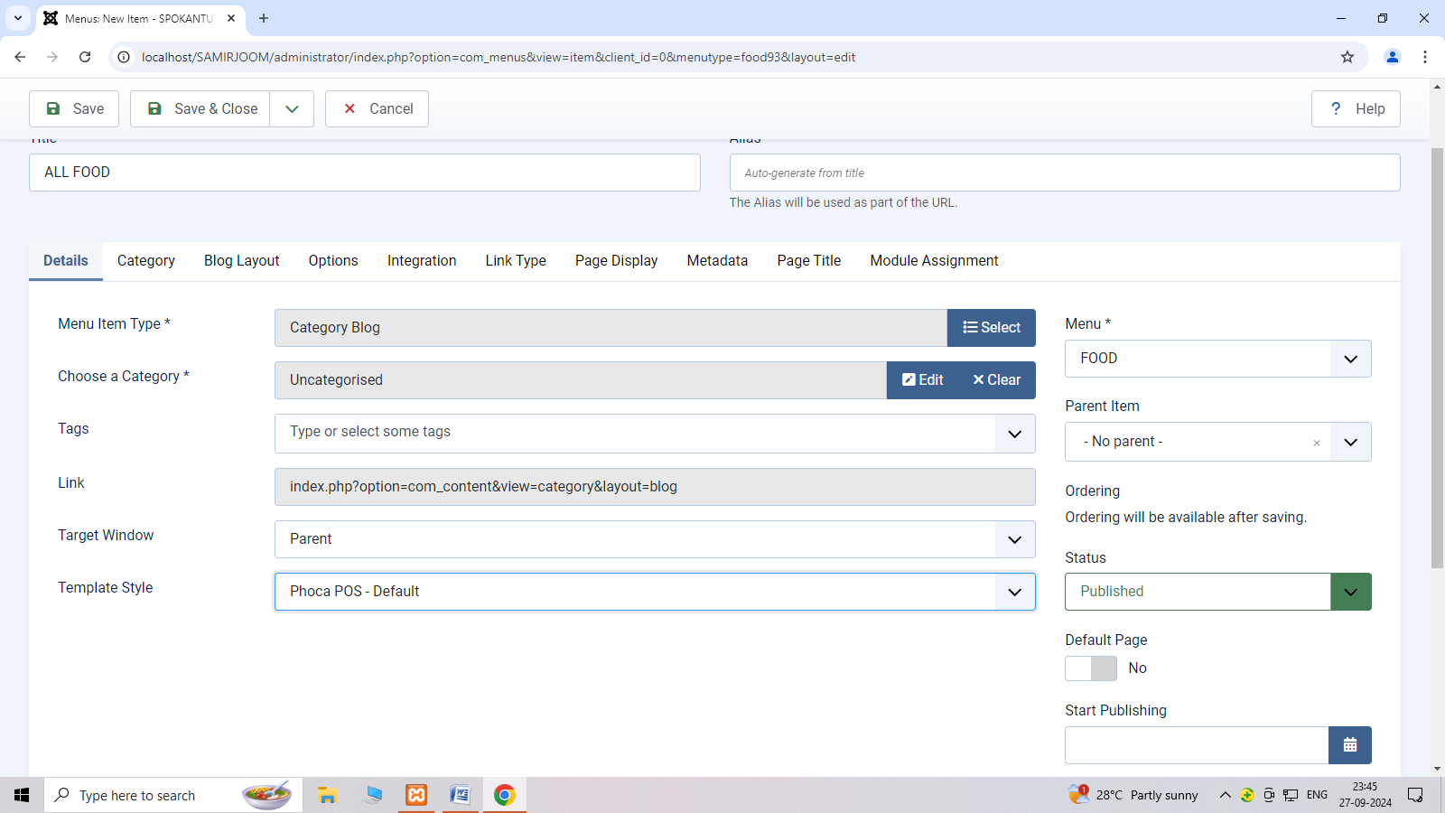

**Step 5:- show menu**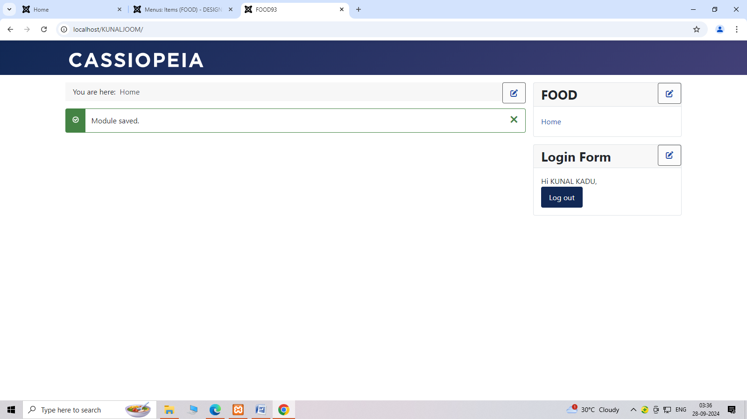

**WAP in Joomla to create the Article.**

**Step:-1 Click on content and choose article option**

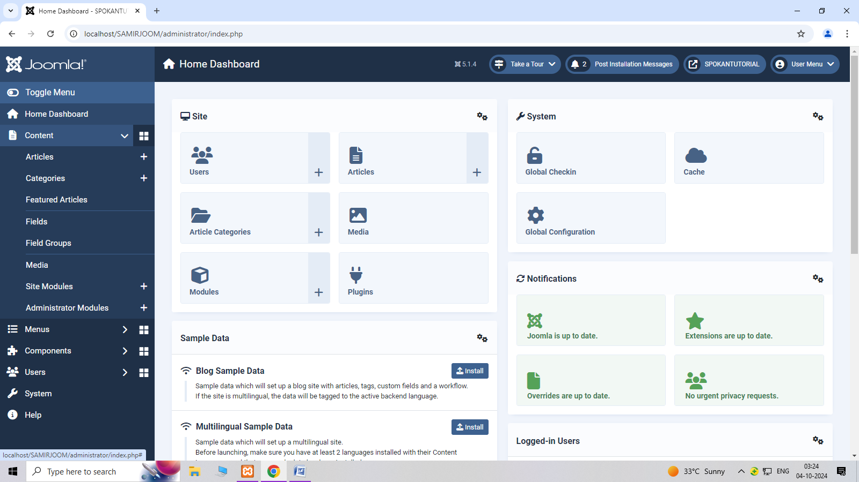

**Step:-2 click on add your first article**

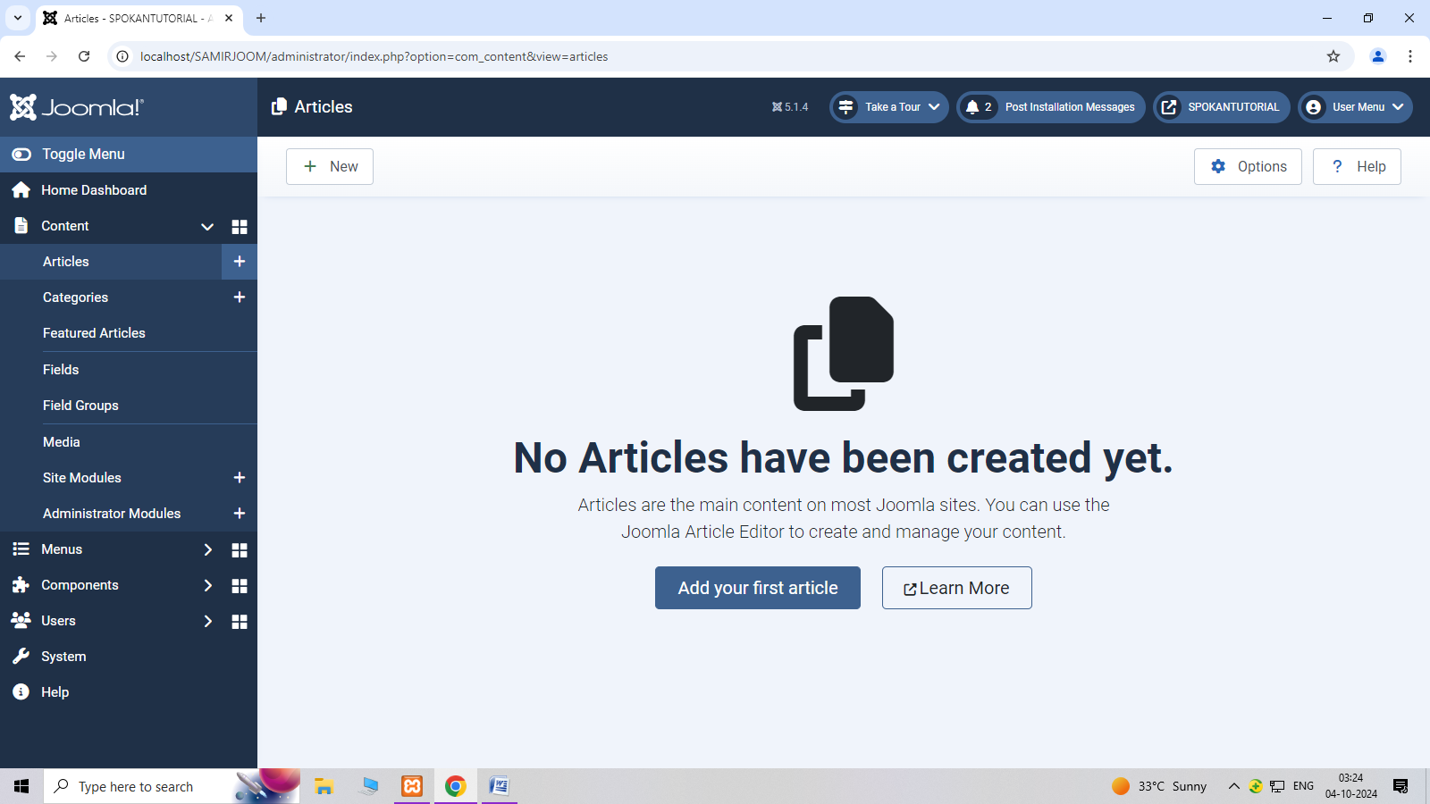

**Step:-3 create new article including(title,image etc)**

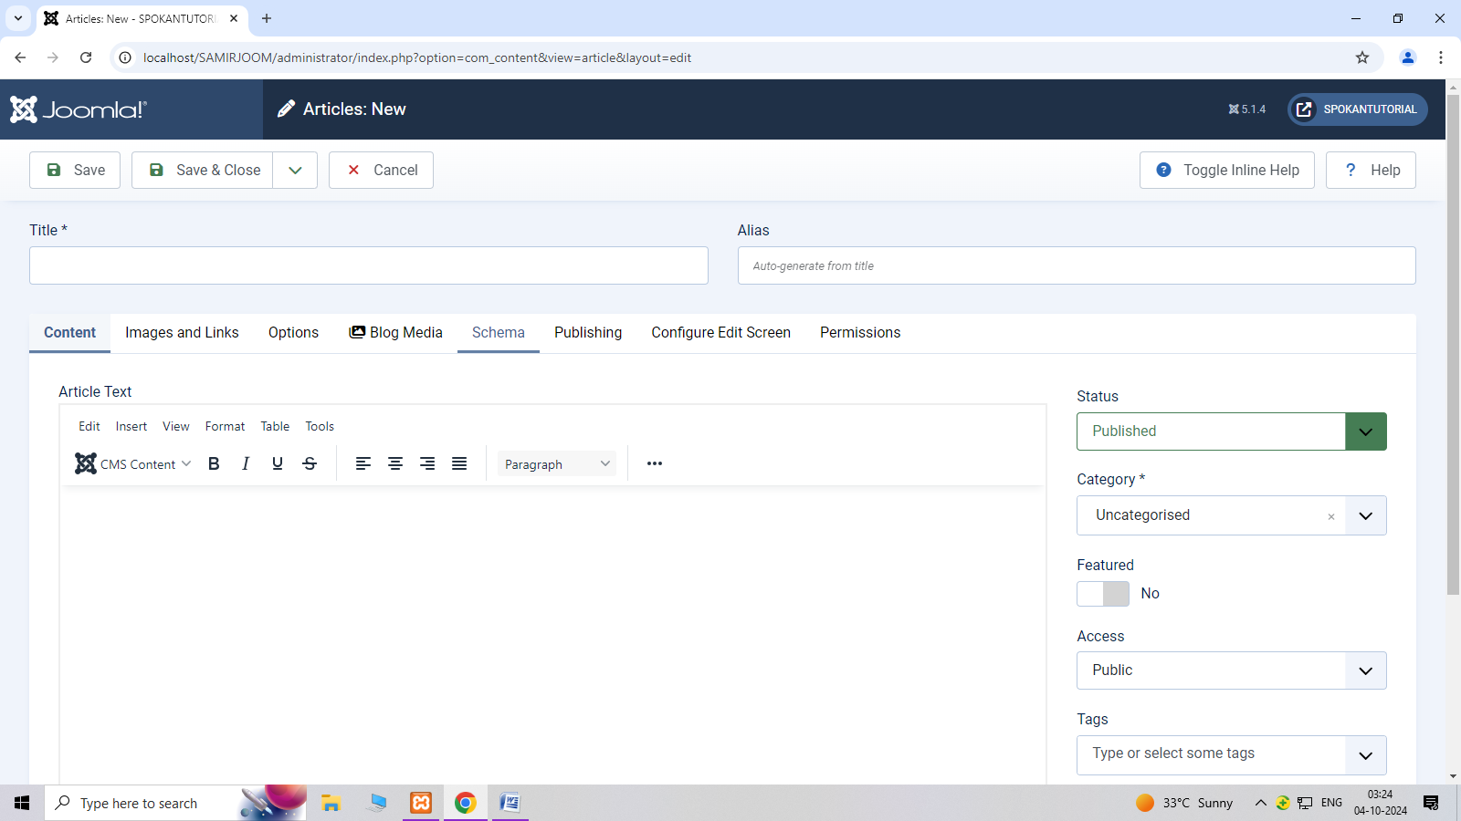

**Step:-4 After create new article show new article in dashboard**.

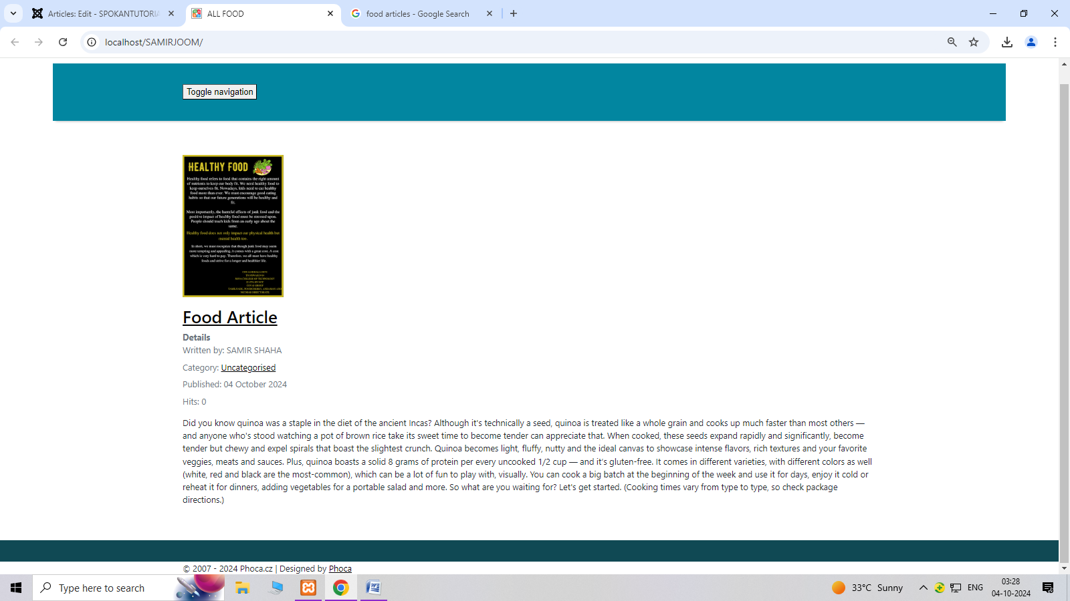

**10.WAP in joomla to create custom mudules on website.**

**Step 1: selecte the sytem and click on site module**

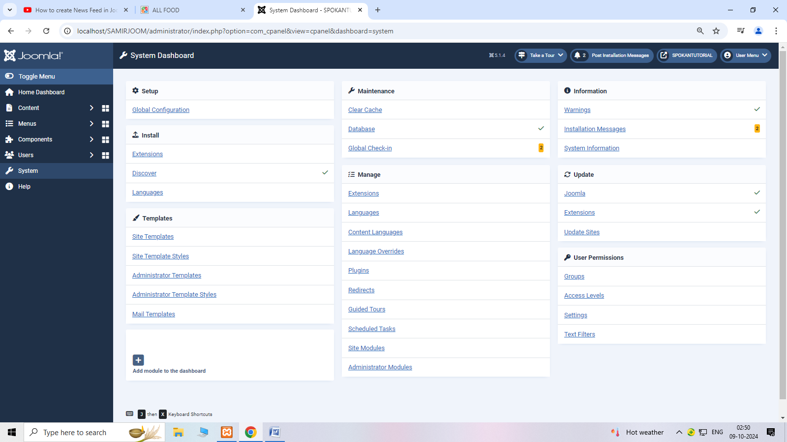

Step 2: click on new option

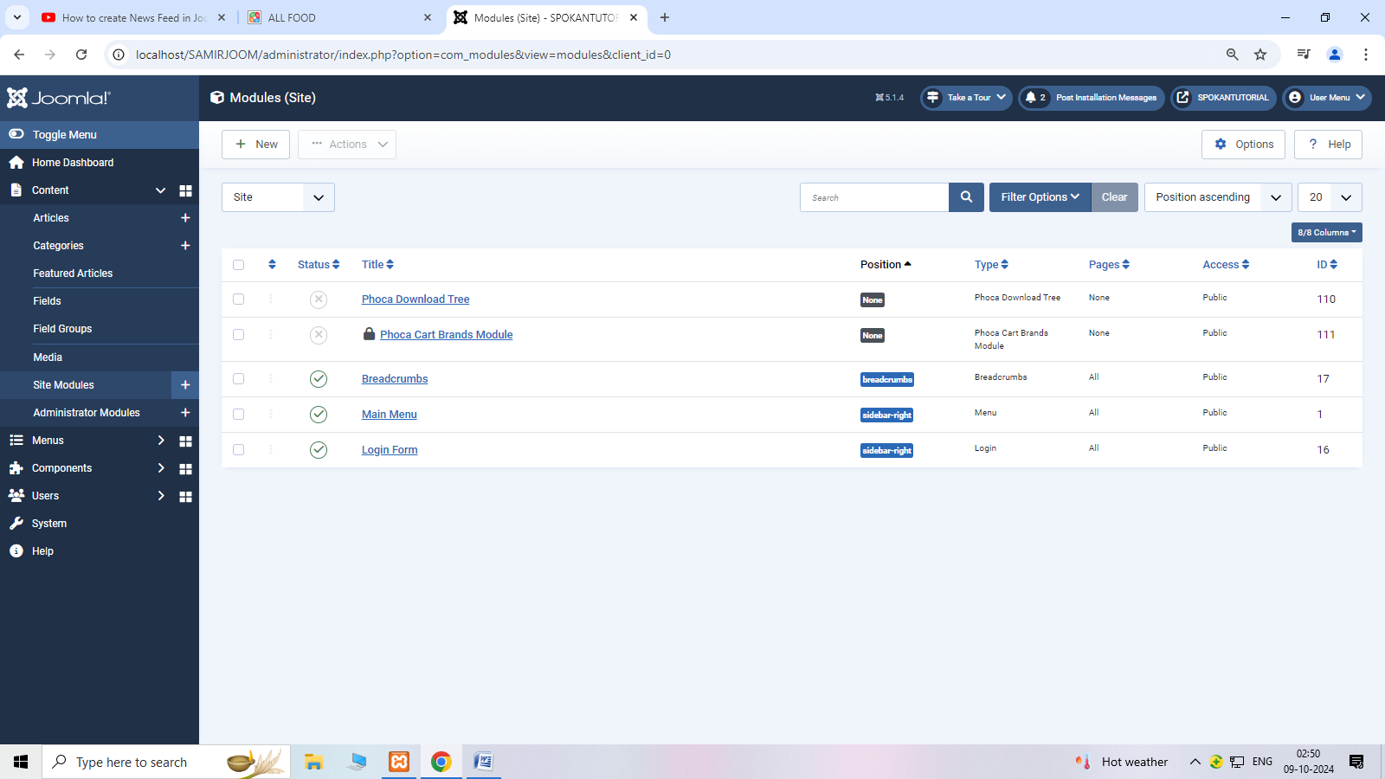

Step 3: after click on new selectee custom.

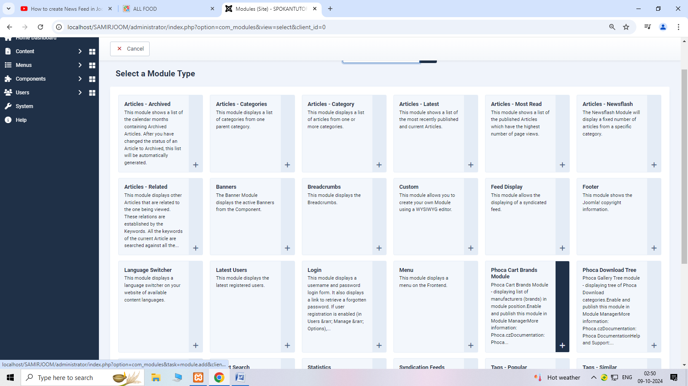

Step 4: create new module step by step.

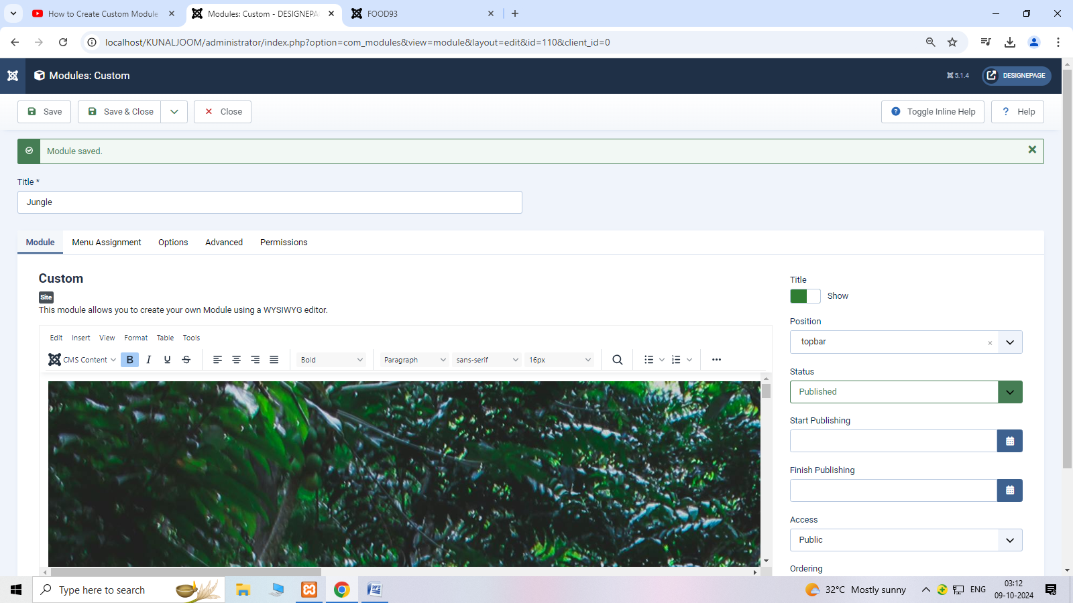

Step 5: after creating module show module on home page.

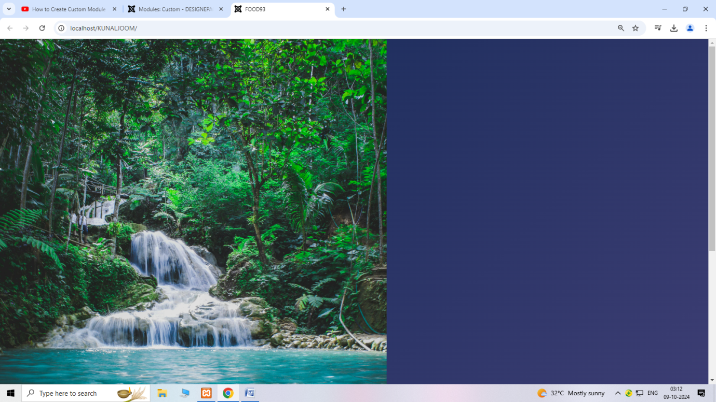

**11.WAPin joomla to create mass e-mailing.**

**Step 1: click on user**

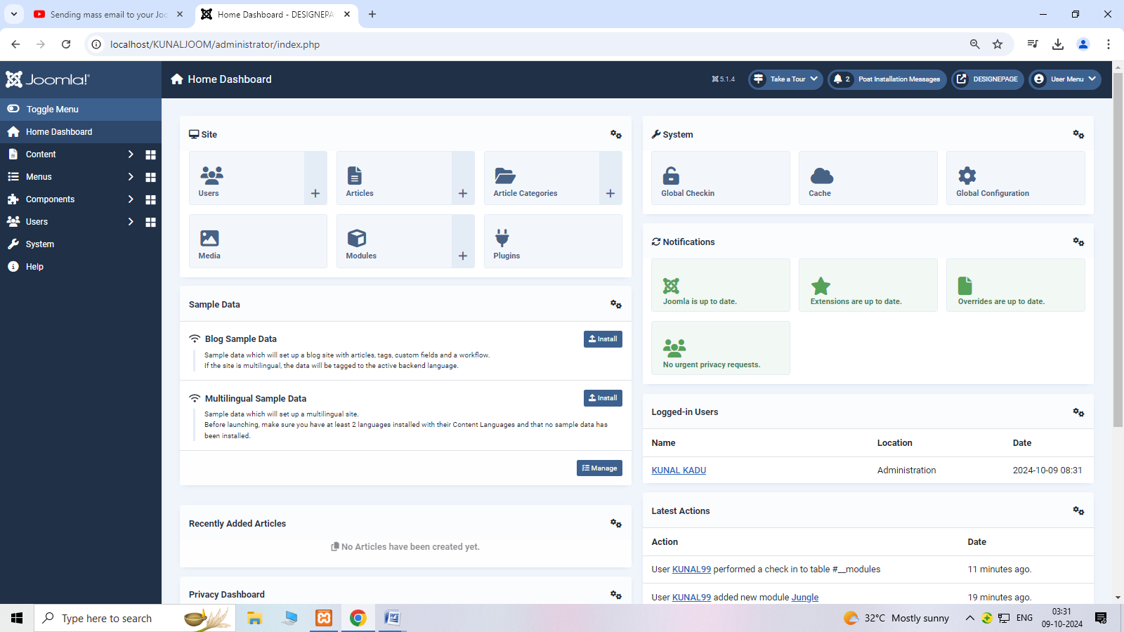

**Step 2: after clicking user selected mass mail user.**

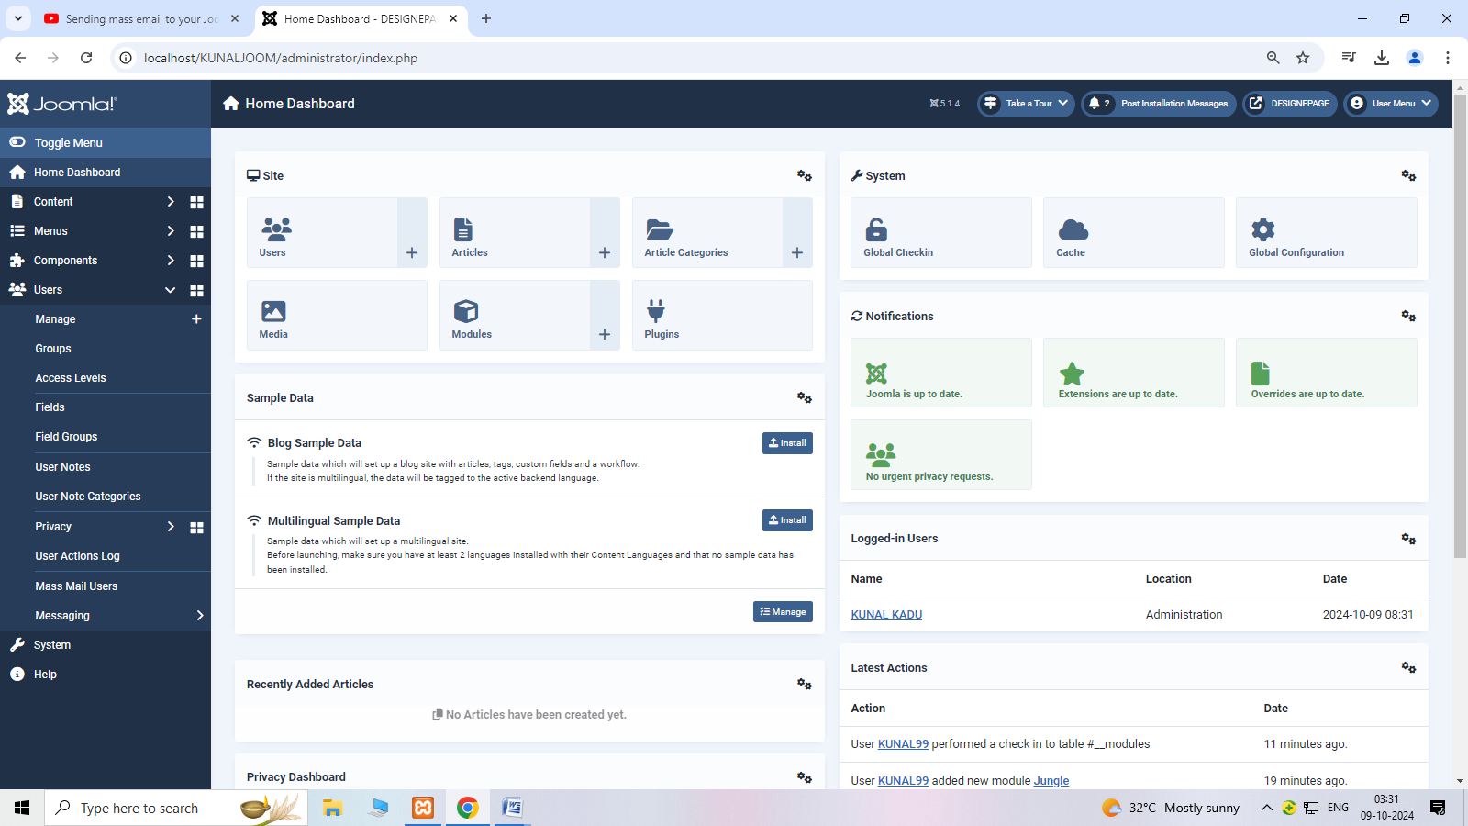

**Step 3: choose subject and write message.**

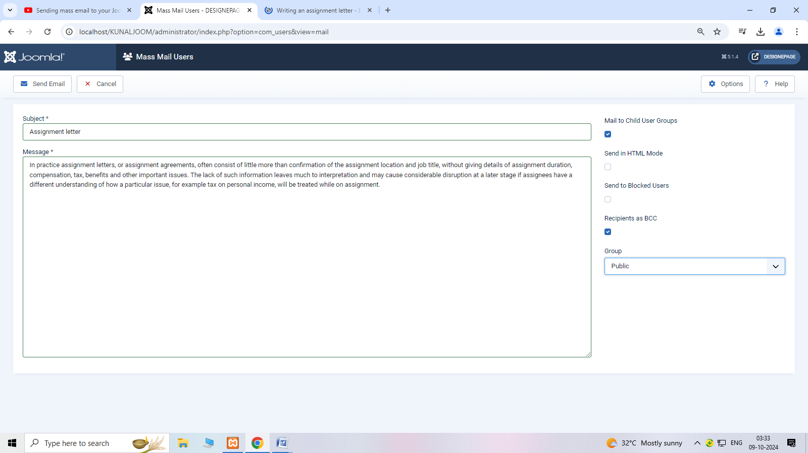

Step 4 : after write message to click on send mail.

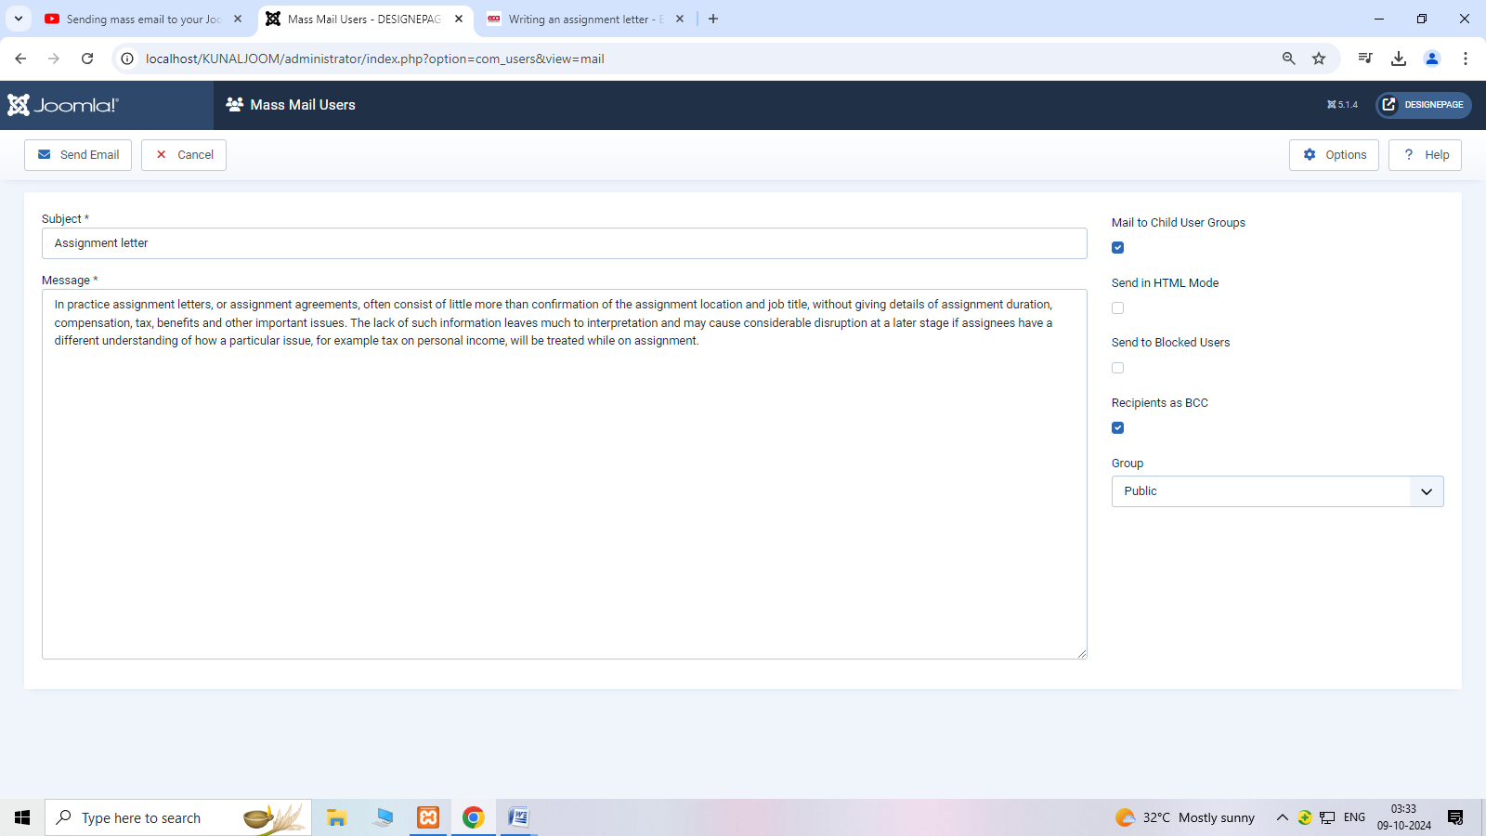

**14.Perform steps Drupal installation.**

Step1: Download Drupal.

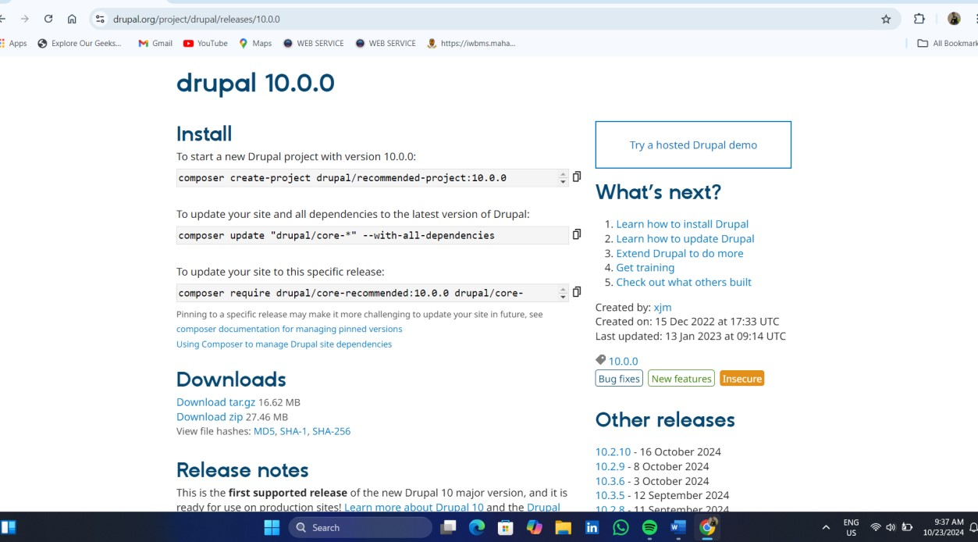

Step2: After downloading Drupal start the xampp server.

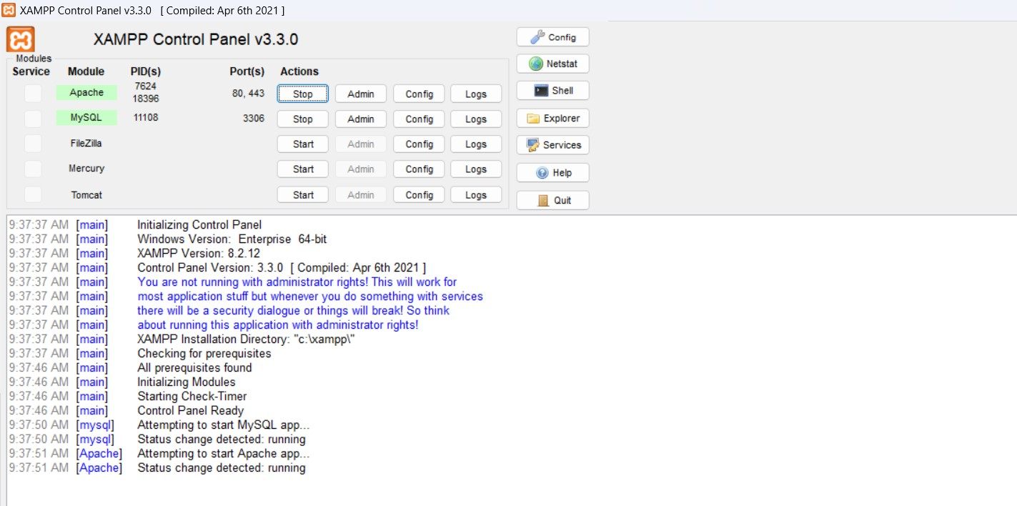

Step3: Select the **Standard** option and click **Save and continue**.

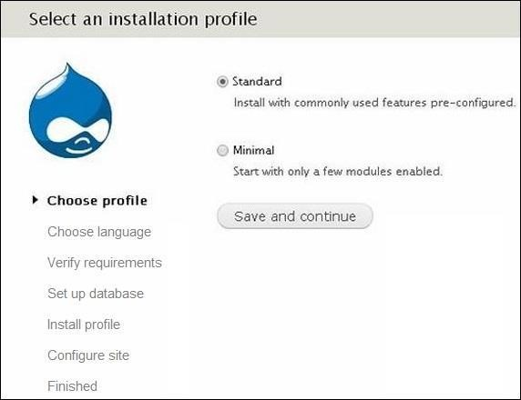

**Step 4** − Select the default language for Drupal website.

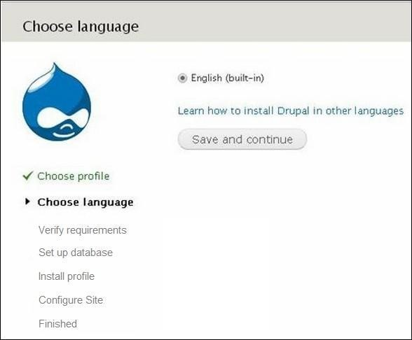

**Step 5** Go to Database configuration page. You need to enter the type of database you will be using, and other details as follows.

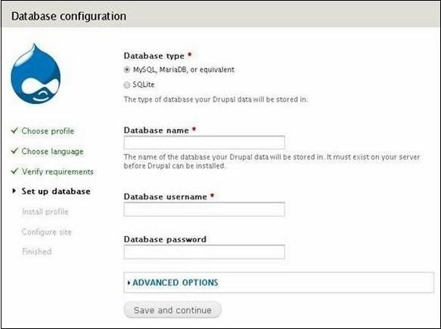

When you click the **ADVANCED OPTIONS**, you will see the following screen.

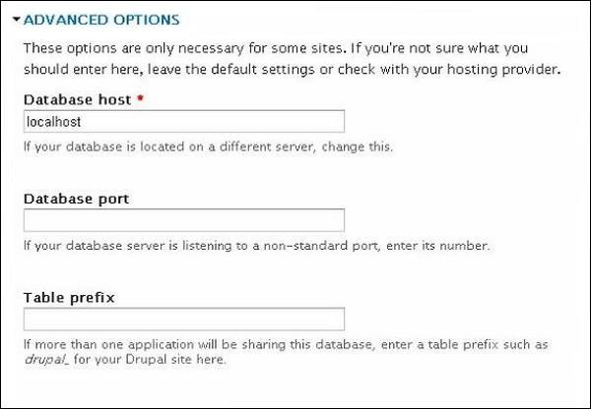

**Step 6** The installation process starts on your machine.

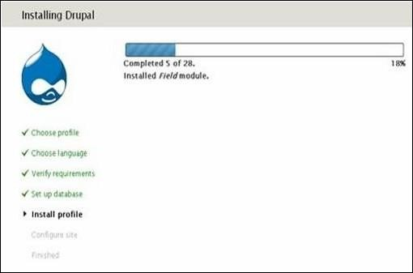

**Step 7** − The Configure site page appears on the screen −

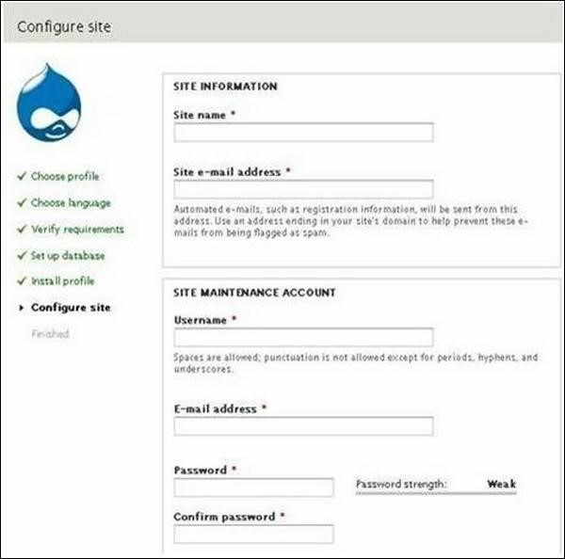

**Step 8** The following page indicating that your Drupal installation is successful will appear on your screen.

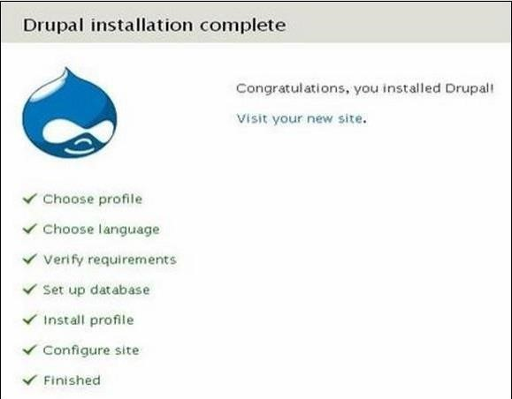

**Step 9** − Click the **Visit your new site** link as shown in this image.

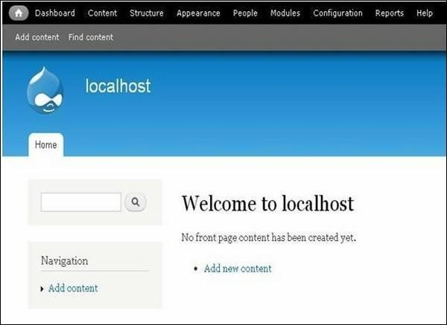

**15.Write a program in Drupal to create Taxonomies.**

**Step 1** − Go to **Structure** and click the **Taxonomy** option.

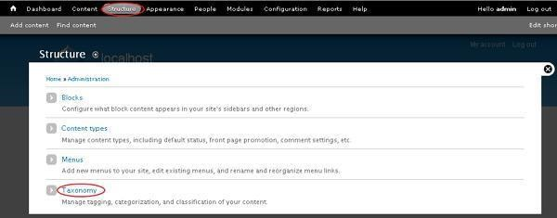

**Step 2** − You can create a new vocabulary for Drupal taxonomy by clicking on **Add vocabulary** link.

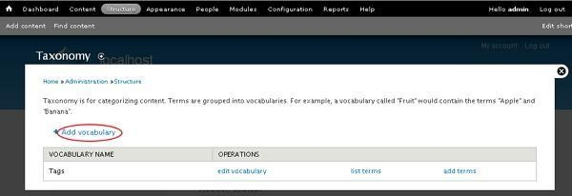

**Step 3** − You will get a screen with **Name** field for adding name for your vocabulary which is mandatory and **Description** field is used for adding description for the vocabulary. Click the **Save** button.

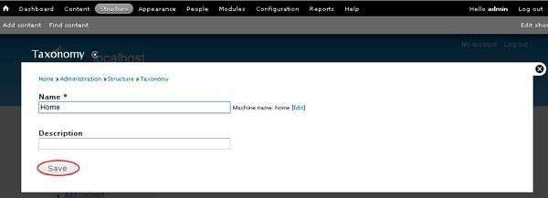

**Step 4** − Click **add terms** to add new terms to the created vocabulary as shown in the following screen.

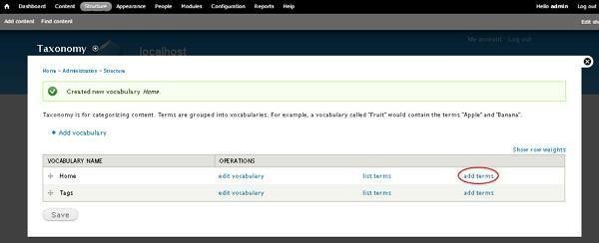

**Step 5** − The screen shows some fields as seen in the following screen. Following are the details of the fields present in the preceding screen.

